**EMPLOYEE PAYROLL MANAGEMENT SYSTEM**

**A Report on Industry Oriented**

**Mini Project Submitted**

**In the partial fulfilment of the requirements for**

**the award of the degree of**

BACHELOR OF TECHNOLOGY

In

COMPUTER SCIENCE & ENGINEERING



By

V. SACHIN BHARADVAJ (21281A0554)

D. AKSHAYA (21281A0549)

N. SAI SRIJA (21281A0509)

V. KARUNAKAR (21281A0526)

PROJECT GUIDE

**Mr. YAKHOOB BANOTHU**

(Assistant Professor)

DEPARTMENT OF COMPUTER SCIENCE & ENGINEERING

**KAMALA INSTITUTE OF TECHNOLOGY AND SCIENCE**

(Approved by AICTE, New Delhi and Affiliated to JNTU, Hyderabad, Accredited with

‘A++’ Grade by NAAC, Accredited by NBA)

Singapur, Huzurabad, Karimnagar, Telangana-505468.

2024–2025

**KAMALA INSTITUTE OF TECHNOLOGY AND SCIENCE**

(Approved by AICTE, New Delhi and Affiliated to JNTU, Hyderabad, Accredited with ‘A++’ Grade by NACC, Accredited by NBA)

SINGAPUR, HUZURABAD, KARIMNAGAR, TELANGANA, INDIA-505468



**CERTIFICATE**

This is to certify that **V. SACHIN BHARADVAJ (21281A0554), D. AKSHAYA (21281A0549), N. SAI SRIJA (21281A0509), V. KARUNAKAR (21281A0526)** of the IV B. Tech Computer Science & Engineering has satisfactorily completed the dissertation work for Industrial Oriented mini project entitled “**EMPLOYEE PAYROLL MANAGEMENT SYSTEM”** towards the partial fulfilment of B. Tech degree in this academic year i.e., 2024-2025.

**Project Guide Head of the Department**

**Principal External Examiner**

**INDEX**

**Title Page No**

**Acknowledgement i**

**Abstract ii**

**List of figures iii**

**List of tables v**

**List of Abbreviations vi**

**Chapter 1 Introduction 1**

1.1 About Project 1

1.2 Existing System 2

1.3 Proposed System 3

**Chapter 2 Analysis 4**

2.1 Hardware Requirements 4

2.2 Software Requirements 4

2.3 Functional Requirements 5

2.4 Non-Functional Requirements 5

2.5 Module Description 6

**Chapter 3 Design 7**

3.1 Block Diagram 7

3.2 Data Flow Diagram 8

3.2.1 DFD Symbols 8

3.2.2 Context Diagram 9

3.3 UML Diagrams 11

3.3.1 Use case Diagram 11

3.3.2 Class Diagram 13

3.3.3 Sequence Diagram 15

3.3.4 Collaboration Diagram 17

3.3.5 Activity Diagram 19

3.4 Database Dictionary 21

3.4.1 Database Tables 21

**Chapter 4 Implementation 24**

4.1 Languages Used 24

4.2 Frontend Design 28

**Chapter 5 Testing 37**

5.1 Testing 37

5.2 Test strategy 39

5.3 Black Box Testing 40

5.4 White Box Testing 42

5.5 Database Testing 43

5.6 Acceptance Testing 44

5.7 Test Results 45

**Chapter 6 Result 46**

**Chapter 7 Conclusion 51**

**Chapter 8 Future Scope & Enhancements 52**

**Bibliography 53**

**ACKNOWLEDGMENT**

The success on any curse depends mostly on the teachers who teach us. Only good teaching can interpret the syllabus and produce desirable changes and competent citizens. This was a team effort and many people whose names do not appear on the cover deserve credit. First, we got all mighty for his manifold mercies in carrying out of our project successfully.

We heartfully thank our Director **Dr K. SHANKER**, and principal **Dr. K. ESWARAIAH**, for providing all the resources in completing our project.

We sincerely thank our Head of the Department of Computer Science & Engineering

**Dr Maj.** **RAVINDRA BABU KALLAM** for encouraging us in doing real time projects, for his guidance and support.

We thank our project coordinators **Mr. K. BHASKAR PRAKASH** Assistant Professor in CSE department for their continuous support in completionof this project**.**

We would like to thank our project guide **Mr. YAKHOOB BANOTHU**, Assistant Professor in CSE for the valuable guidance and constant encouragement at each stage of this project.

We also thank other teaching and non-teaching staff of Kamala Institute of Technology and Science, for supporting us in every stage of our mini project, entitled “**EMPLOYEE PAYROLL MANAGEMENT SYSTEM”**. We also thank our parents and friends for their moral support throughout the project work that helped to strengthen our will.

**V. SACHIN BHARADVAJ (21281A0554)**

**D. AKSHAYA (21281A0549)**

**N. SAI SRIJA (21281A0509)**

**V. KARUNAKAR (21281A0526)**

**I**

**ABSTRACT**

The **Employee Payroll Management System** is a comprehensive web-based application designed to stream line the management of employee records, salary details, and leave applications. Built using **Flask** for backend services and **MongoDB** for data storage, the system provides role-based access for both **administrators** and **employees**. Administrators can add, update, and delete employee details, manage payroll information including basic salary, allowances, deductions, and bonuses, and oversee leave applications. Employees can log in to view their personal details, submit leave requests, and check the status of those requests. The system uses secure authentication and session management with **BCRYPT** for password encryption, ensuring the protection of sensitive data. Its user-friendly interface, powered by HTML, CSS, and JavaScript, allows for seamless navigation and interaction between different functionalities. The system aims to enhance organizational efficiency by automating payroll and leave management processes, reducing errors, and ensuring timely and accurate salary calculate.

**II**

**LIST OF FIGURES**

**TITLE PAGE NO**

Figure 3.1 Block Diagram 7

Figure 3.2.1 DFD Diagram 8

Figure 3.2.2.1 Zero Level DFD 9

Figure 3.2.2.2 Level-1 DFD(Admin) 10

Figure 3.2.2.3 Level-2 DFD(User) 10

Figure 3.3.1.1 Admin Use Case Diagram 11

Figure 3.3.1.2 Employee Use Case Diagram 12

Figure 3.3.2 Employee payroll Class Diagram 13

Figure 3.3.3.1 Admin Sequence Diagram 16

Figure 3.3.3.2 Member Sequence Diagram 17

Figure 3.3.4.1 Admin Collaboration Diagram 18

Figure 3.3.4.2 User Collaboration Diagram 18

Figure 3.3.5.1 Employee Activity Diagram 19

Figure 3.3.5.2 Admin Activity Diagram 20

Figure 3.4.1.1 MongoDB 21

Figure 3.4.1.2 DB Collections Table 22

Figure 3.4.1.3 Employees Table 22

Figure 3.4.1.4 Employees Details Table (Admin View) 23

Figure 3.4.1.5 Leaves Table (Admin View) 23

Figure 4.2.1 Screenshot of logo page 29

Figure 4.2.2 Screenshot of login page 30

Figure 4.2.3 Screenshot of Registration page 30

Figure 4.2.4 Screenshot of Admin Home page 31

Figure 4.2.5 Screenshot of Employee Details page 32

Figure 4.2.6 Screenshot of Add Employee page 33

Figure 4.2.7 Screenshot of Salary Details page 34

Figure 4.2.8 Screenshot of View Leaves page 34

Figure 4.2.9 Screenshot of User Home page 35

Figure 4.2.10 Screenshot of Leave application page 36

Figure 4.2.11 Screenshot of profile page 36

Figure 5.1.1 All Fields are empty 37

**III**

Figure 5.1.2 All Fields are filled 38

Figure 5.1.3 Admin Home page 38

Figure 5.1.4 User Home Page 39

Figure 5.3.1 The Admin has logged in successfully 40

Figure 5.3.2 The User has logged in successfully 41

Figure 5.4 The Admin/User has failed invalid login credentials 42

Figure 5.5.1 Database Employee Details data 43

Figure 5.5.2 Database Employee Details 43

Figure 5.5.3 Database leaves 44

Figure 5.5.4 Database leaves Data 44

Figure 5.6 Acceptance Testing 45

Figure 6.1 Screenshot of Admin Home Page 46

Figure 6.2 Screenshot of Employee Details Page 47

Figure 6.3 Screenshot of Add Employee Page 47

Figure 6.4 Screenshot of Salary Page 48

Figure 6.5 Screenshot of View Leaves Page 48

Figure 6.6 Screenshot of User Home Page 49

Figure 6.7 Screenshot of Leaves Page 49

Figure 6.8 Screenshot of Profile Page 50

**IV**

**LIST OF TABLES**

**TITLE PAGE NO**

Table 3.2.1 Data Flow Diagram Symbols 8

Table 3.4.1.1 Mongo DB 21

Table 3.4.1.2 DB Collections Table 22

Table 3.4.1.3 Employees Table 22

Table 3.4.1.4 Employee Details Table (Admin view) 23

Table 3.4.1.5 Leaves table (Admin view) 23

**V**

**LIST OF ABBREVIATIONS**

HTML Hypertext Markup Language

CSS Cascading Style Sheets

UML Unified Modelling Language

GUI Graphical User Interface

JS Java Script

**VI**

**CHAPTER 1**

**INTRODUCTION**

* 1. **About project:**

The Employee Payroll Management System is a comprehensive software solution designed to manage employee payroll and leave records efficiently. The system is built with two primary user roles: Admin and Employee, each with distinct access levels and functionality. Admins have full control over the system and can view and manage all employee details, including leaves, salary information, deductions, and bonuses. They are responsible for updating employee records, handling payroll processing, and approving or denying leave requests. Admins can also generate reports for payroll and ensure compliance with organizational policies.

For employees, the system provides a simplified interface, allowing them to access only their own details. Employees can view their salary breakdown, including base salary, allowances, and deductions, ensuring transparency in their earnings. They can also monitor their leave balance and submit leave requests directly through the system. Once submitted, these requests are sent to the admin for approval, and the employee is notified of the decision in real time. This reduces paperwork and speeds up the leave approval process.

Data security is a key feature, as only Admins have access to all employee records, ensuring confidentiality. Employees can only view their personal information, safeguarding privacy across the platform. The system is designed to be flexible, allowing Admins to customize payroll cycles, leave accrual rules, and deductions to fit the organization’s policies.

By automating payroll calculations, leave management, and reporting, the Employee Payroll Management System enhances accuracy and reduces the administrative burden on HR departments. It provides a reliable, secure, and user-friendly environment for both Admins and Employees, ensuring smooth payroll and leave management processes.Top of Form

**1**

Bottom of Form

* 1. **Existing System with drawbacks:**
* If employee data (including salaries and complaints) is not well protected, it could lead to privacy issues or data leaks.
* It may be difficult to track past payroll data, complaints, and leave records for long-term decision-making.
* Limited-Service Options: Some platforms might have a limited range of services available, restricting users in terms of the type of services they can access or providers they can choose from.
* Poor User Experience: Complicated interfaces. lack of real-time tracking, or unclear communication channels between users and service providers can lead to a subpar user experience, impacting customer satisfaction.
* There is no way to filter or search for specific employees, which could be cumbersome in larger datasets.
* If the number of employees grows, loading all employee data into the table at once can become inefficient and slow down the page.

* 1. **Proposed System with Features:**

The proposed system automates payroll and leave management, allowing Admins to efficiently manage all employee details, including leaves, salary, deductions, and bonuses. Admins can access and update all employee records, while employees can only view their own salary details, leave balances, and submit leave requests through a user-friendly interface. Leave requests are automatically sent to Admins for approval, and employees are notified of the decision in real time. This system enhances data accuracy, improves workflow efficiency, and ensures privacy by restricting access to sensitive information based on user roles.

**2**

**Features:**

**1. Employee Data Management:**

- Store employee personal and professional details

- Track employee leave, attendance

**2. Payroll Processing:**

- Calculate salaries, taxes, and deductions

**3. Leave Management:**

- Track and approve leave requests

- Calculate leave balances and deductions

**4. Benefits and Deductions:**

- Manage employee benefits (e.g., health insurance, retirement plans)

- Calculate deductions (e.g., taxes, loan repayments)

**5. User Access and Security:**

- Control access to payroll data and functions

- Ensure data security and confidentiality

**6. Integration and Automation:**

- Integrate with HR systems, accounting software, and banks

- Automate payroll processes and reduce manual errors

**7. Employee Self-Service:**

- Allow employees to view leave balances, and benefits

- Enable employees to request leaves and view previous history

**8. Alerts and Notifications:**

- Send reminders for payroll processing, leave requests, and important deadlines

- Notify employees and management of payroll-related updates

**3**

**CHAPTER 2**

**ANALYSIS**

**2.1 Hardware Requirements (Preferable):**

The selection of hardware is very important in the existence and proper working of any software. In the selection of hardware, the size and the capacity requirements are also important and are shown in table 2.1.

**Table: 2.1 Hardware Requirements**

|  |  |
| --- | --- |
| Process | Any processor speed with 1.1 GHz |
| RAM | 1 GB |
| Hard Disk Capacity | 40 GB |
| Monitor | Any Monitor |
| Keyboard | Standard Keyboard |
| Mouse | Two or Three Button Mouse |

**2.2 Software Requirements:**

One of the most difficult tasks is the selection of the software, once system requirements are known that determine whether a particular software package fits the requirements are shown in table 2.2

**Table: 2.2 Software Requirements**

|  |  |
| --- | --- |
| Operating System | Windows XP/7/8/9/10/11 LINUX Scripting |
| Language | Python |
| Front End | HTML, CSS, JavaScript, |
| Database | MongoDB |
| IDE | Visual Studio code 1.93.1 |
| Framework | Flask |

**4**

**2.3 Functional Requirements:**

Functional requirements are associated with specific functions, tasks or behaviour of the system must support. The functional requirements address the quality characteristic of functionality while other quality is concerned with various kinds of non-functional requirements. Because non-functional requirements tend to be stated in terms of constraints on the results of tasks which are given as functional requirements (e.g., constraints on the speed or efficiency of a given task), a task-based functional requirements statement is a useful skeleton upon which to construct a complete requirements statement.

The following are the functional requirements of our project. They are:

• A database must be created to maintain the details of employee.

• It should be very efficient in retrieval of information.

• It shouldn't accept null values whenever validated.

**2.4 Non-Functional Requirements:**

Non-functional requirements are requirements that specify criteria that can be used to judge the operation of a system, rather than specific behaviour. This should be contrasted with functional requirements that specify specific behaviour or functions. In general, functional requirements define what a system is supposed to do whereas non-functional requirements define how a system is supposed to be. Non-functional requirements are often called qualities of a system. Other terms for non-functional requirements are "constraints", "quality attributes", "quality goals" and "quality of service requirements" Qualities. Non-functional requirements can be divided into two main categories. As this is a website, it provides the following non-functional requirements:

**Security:** This System provides the password access control to avoid unauthorized member to login.

**Reliability:** This portal provides effective method to maintain the back – end to store all the details securely.

**Scalability:** This system is easy to operate and quick in response as it has ability to handle the increasing number of members.

**Availability:** As System provides the member to login the application and view the content so he/she can access it 24x7 remotely.

**5**

**2.5 Module Description:**

**1. Admin Module**

- **Employee Management:** Admin can add, update, or delete employee details including personal and salary information.

- **Payroll Management:** Admin can generate employee salaries, view salary details, and manage salary structures like bonuses and deductions.

- **Leave Management:** Admin can manage employee leave applications, maintain records and track leave balances for each employee.

- **User Access Control:** Admin can manage access permissions and roles for the employees, ensuring that only authorized person have access to certain data.

**2. Employee (User) Module**

**- Profile View:** Employees can view their own profile information, such as personal details and employment data.

**- Salary Details:** Employees can view their salary slips, deductions, bonuses.

- **Leave Application**: Employees can apply for leave, view leave balances, and track the status of leave applications.

**6**

**CHAPTER 3**

**DESIGN**

**3.1 Block Diagram:**

The Block Diagram is typically used for a higher level, less detailed description aimed more at understanding the overall concepts and less at understanding the details of Implementation [4]. Main operations are to add, view and update the details of the users, resources. The following Figure 3.1 represents the block diagram.

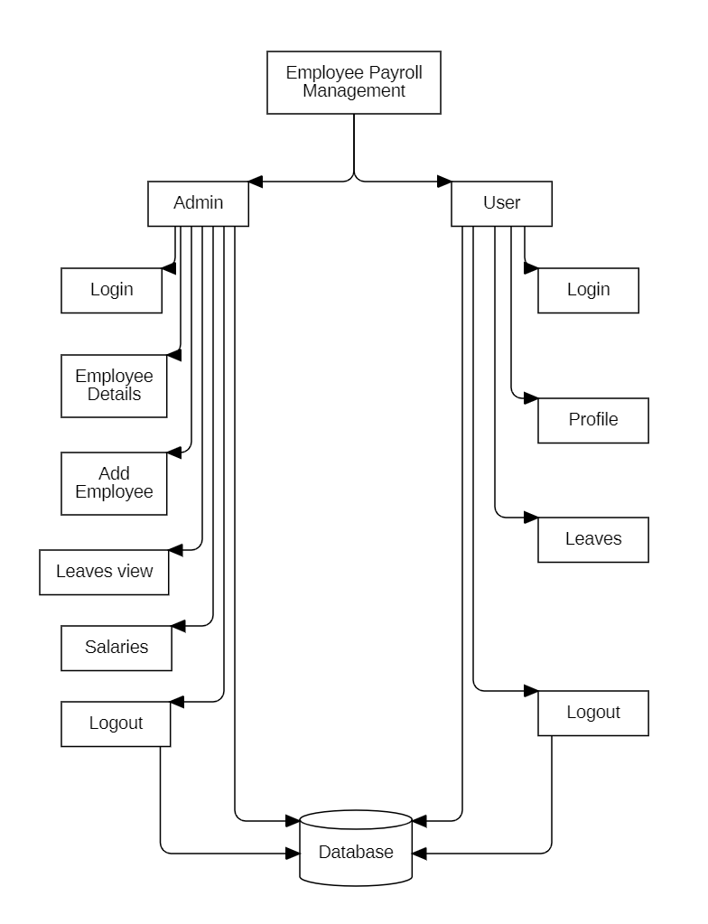

**Figure 3.1 Block Diagram**

**7**



**3.2 Data Flow Diagram:**

A data flow graph is a graphical tool used to describe and analyze movement of data through a system. These are the central tool and the basis from which the other components are developed. The transformation of data from input to output, through processed, may be described logically and independently of physical components associated with the system. This is known as the logical data flow diagrams. The physical data flow diagrams show the actual implements and movement of data between people, departments and workstations. Each component in a DFD is labelled with a descriptive name. Process is further identified with a number that will be used for identification purpose. Each process in lower-level diagrams can be broken down into a more detailed DFD in the next level. The top-level diagram is often called a “context diagram”.

**3.2.1 DFD Symbols:**

In the DFD, there are four symbols

• Square defines a source (originator) or destination of system data.

• An arrow identifies data flow. It is the pipeline through which the information flows. Data move in a specific direction from an origin to a destination.

• A circle or a bubble represents a process that transforms incoming data flow into outgoing data flows.

• An Open Rectangle is a data store, data at rest or a temporary repository of data. The following figure 3.2.1 shows the symbols of DFD.

|  |  |
| --- | --- |
| **Symbol** | **Elementary** |
|  | Process or transforms data |
|  | Data Flow |
|  | Source or Destination |
|  | Data store |

**Table 3.2.1 DFD Symbols**

**8**

**Constructing a DFD:**

Several rules of thumb are used in drawing DFD’S:

• Process should be named and numbered for an easy interface. Each name should be representative of the process.

• The direction of flow is from top to bottom and from left to right. Data traditionally flow from source to the destination although they may flow back to the source. One way to indicate this is to draw long flow line back to a source.

• An alternative way is to repeat the source symbol as the destination. Since it is used more than once in the DFD it is marked with a short diagonal.

• When a process is exploded into lower-level details, they are numbered.

• The names of data stores and destinations are written in capital letters. Process and dataflow names have the first letter of each work capitalized.

**3.2.2 Context Diagram:**

It contains a single process, but it plays a very important role in studying the current system. The context diagram defines the system that will be studied in the sense that it determines the boundaries. Anything that is not inside the process identified in the context diagram will not be part of the system study. It represents the entire software element as a single bubble with input and output data indicated by incoming and outgoing arrows respectively. A DFD is also known as a “bubble chart” has the purpose of clarifying system requirements and identifying major transformations that will become programs in system design. So, it is the starting point of the design to the lowest level of detail. A DFD consists of a series of bubbles joined by data base system. This website has two-levels of DFDs. Fig 3.2.2.1 represents Level Zero DFD. This figure represents the login and logout of both admin and member to the website. In the website the details entered will be stored in database and can be retrieved at required time. Identically, the Fig 3.2.2.2 and 3.2.2.3 represents Level One DFD. The figure gives the detailed information about the actions performed by the admin on the website along with login and logout.

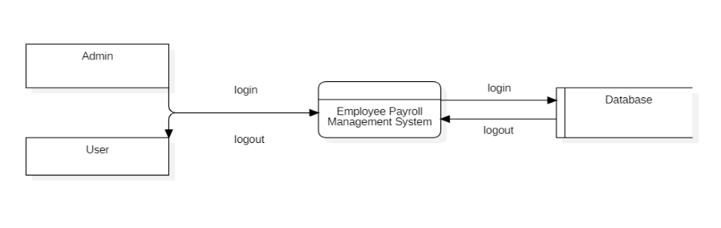

**Figure 3.2.2.1 Zero Level DFD**

**9**

**Admin DFD:**

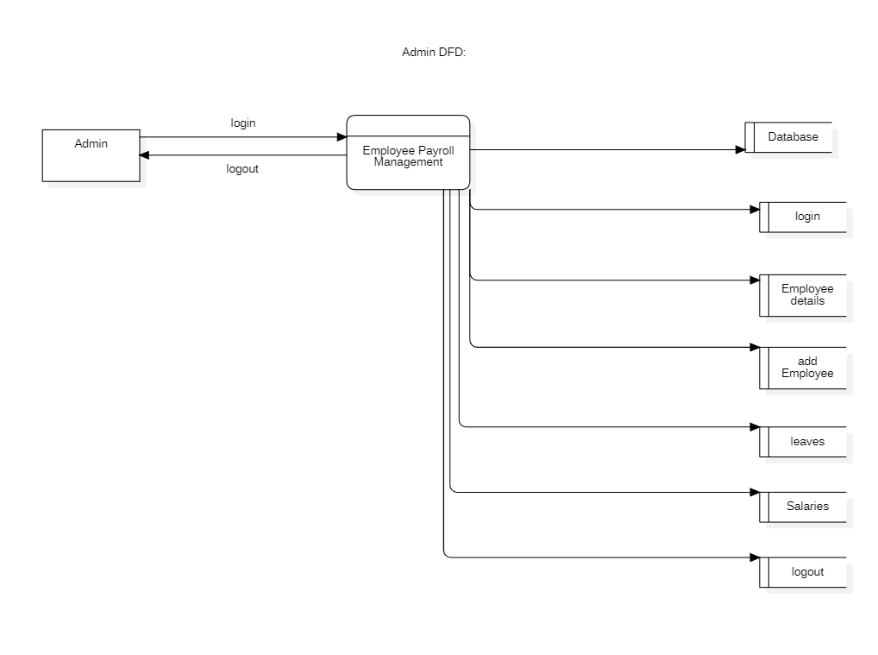

**Figure 3.2.2.2 Level-1 DFD (Admin)**

**User DFD:**

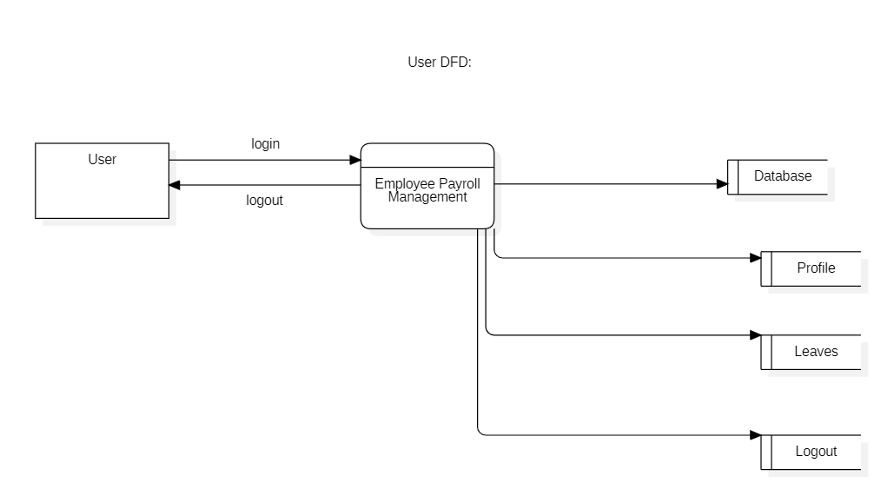

**Figure 3.2.2.3 Level-1 DFD (User)**

**10**

**3.3 UML Diagrams:**

UML stands for Unified Modelling Language. UML is a language for specifying, visualizing and documenting the system. This is the step while developing any product after System analysis [1]. The goal from this is to produce a model of the entities involved in the project which later need to be built. The representation of the entities that are to be used in the product being developed need to be designed. There are various kinds of methods in software design:

They are as follows:

1. Use Case Diagram

2. Class Diagram

3. Sequence Diagram

4. Collaboration Diagram

5. Activity Diagram

**3.3.1 Use Case Diagram:**

Use case diagrams [1] are one of the five diagrams in the UML for modelling the dynamic Aspects of the systems (activity diagrams, sequence diagram, state chart diagram, collaboration diagram are the four other kinds of diagrams in the UML for modelling the dynamic aspects of systems). Use case diagrams are central to modelling the behaviour of the system, a sub-system, or a class. Each one shows a set of use cases and actors and relations [5].

The key points are:

* The main purpose is to show the interaction between the use cases and the actor.
* To represent the system requirement from the user's perspective.
* Use cases are the functions that are to be performed in the module.

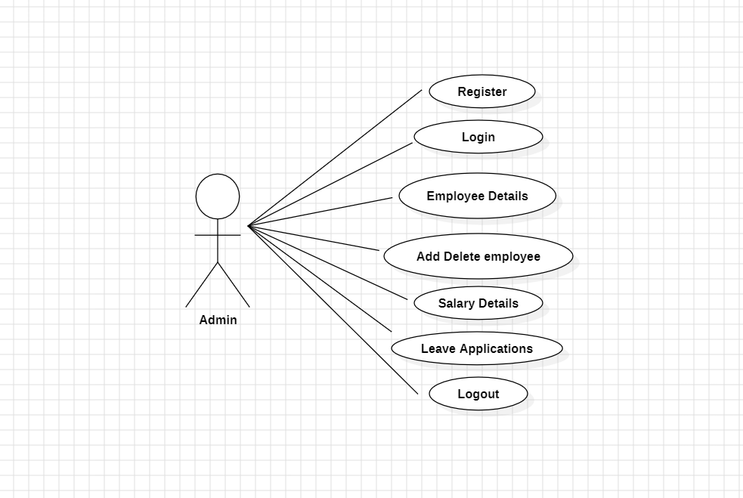

**Figure 3.3.1.1 Admin Use Case Diagram**

**11**

The main use cases of figure are:

**• Register:**

**• Login:** The admin logs in to the system.

**• Employee Details:** Admin can view employee details.

**• Add delete employee:** Admin can add/delete employee.

**• Salary Details:** Admin can view salary details.

**• Leave Applications:** Admin can view leave applications.

**• Logout:** The admin logs out of the system.

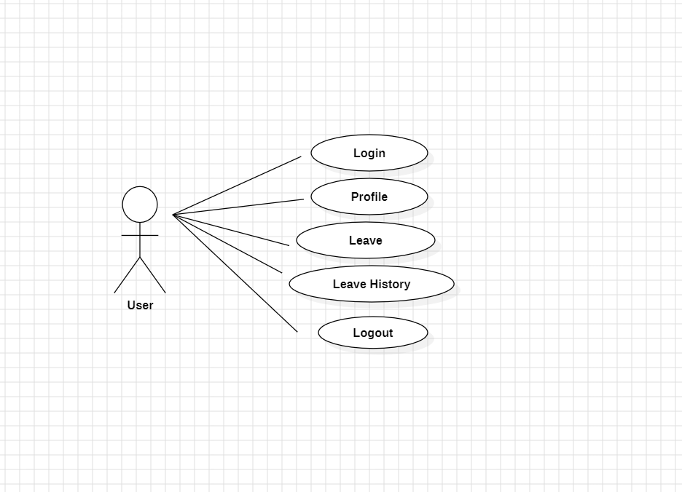

**Figure 3.3.1.2 Employee Use Case Diagram**

**12**

The main use cases of figure are:

**• Login:** An existing employee can log in to their account.

**• View Profile**: Employee can view his/her profile.

**• Leave:** Employee can apply for leave.

**• Leave History:** Employee can view leave history.

**• Logout:** An employee can log out of their account.

**3.3.2 Class Diagram:**

Class is nothing but a structure that contains both variables and methods. The Class Diagram shows a set of classes, interfaces, and collaborations and their relationships. There is most common diagram in modelling the object-oriented systems and are used to give the static view of a system. It shows the dependency between the classes that can be used in our system. The interactions between the modules or classes of our projects are shown below. Each block contains Class Name, Variables and Methods.

The class diagram of Employee Payroll Management website is shown in the **figure 3.3.2**, it contains classes which have class name, attributes, operations is to be performed. Class name includes admin, employee. Attributes are related features to the class name they include id, name, etc. Operations performed by the class are create (), update (). Consider member class the attributes include name, gender, phone, email, password etc.

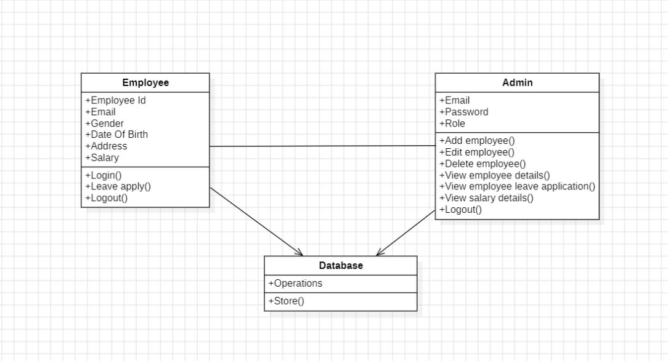

**Figure 3.3.2 Employee Payroll Class Diagram**

**13**

The class diagram **(Figure 3.3.2)** of the employee payroll shows the following classes:

**•** Employee

**•** Admin

**•** Database

The classes are connected by the following relationships:

**•** Employee has a one-to-many relationship with Database. This means that one member can have multiple database entries, but each database entry can only belong to one member.

**•** Admin has a one-to-many relationship with employee**.** This means that one admin can perform their operations.

**•** Database has a bidirectional many-to-many relationship with Admin. This means that many database entries can be managed by many admins, and many admins can manage many database entries.

The classes have the following attributes:

**Employee**

**•** Employee Id

**•** Email

**•** Gender

**•** Date Of Birth

**•** Salary

**•** Address

**Admin**

**•** Email

**•** Password

**•** Role

**Database**

The Employee class has the following operations:

**•** Login ()

**•** Logout ()

**14**

The admin class has the following operations:

**•** Add employee ()

**•** Delete employee ()

• View employee details ()

**•** View employee leave applications ()

**•** View salary details ()

**•** Logout ()

The Database class has the following operations:

**•** Store ()

The class diagram shows the static structure of the Employee payroll management system. It shows the different classes that make up the system and the relationships between them. The class diagram can be used to help understand the system and to identify the requirements for the system.

**3.3.3 Sequence Diagram:**

Sequence diagram and collaboration diagram are called INTERACTION DIAGRAMS. An interaction diagram shows an interaction, consisting of set of objects and their relationship including the messages that may be dispatched among them. A sequence diagram is an introduction that empathizes the time ordering of messages. Graphically a sequence diagram is a table that shows objects arranged along the X-axis and messages ordered in increasing time along the Y-axis.

Sequence diagram represents the process of website working in a certain sequence order. In sequence diagram verification is displayed for every login. The **Figure 3.3.3.1** represents the Admin Sequence Diagram and the **Figure 3.3.3.2** represents the Employee Sequence Diagram.

In Admin Sequence Diagram the lifelines are Admin, Website, Database. Admin firstly, login to the website and the website verifies the login details i.e., email and password from the database. At his convenient the admin can logout from the website, database shows that logout was successful.

In Employee Sequence Diagram the lifelines are Employee, Website, Database. Employee firstly, login to the website and the website verifies the login details i.e., email and password from the database.

**15**

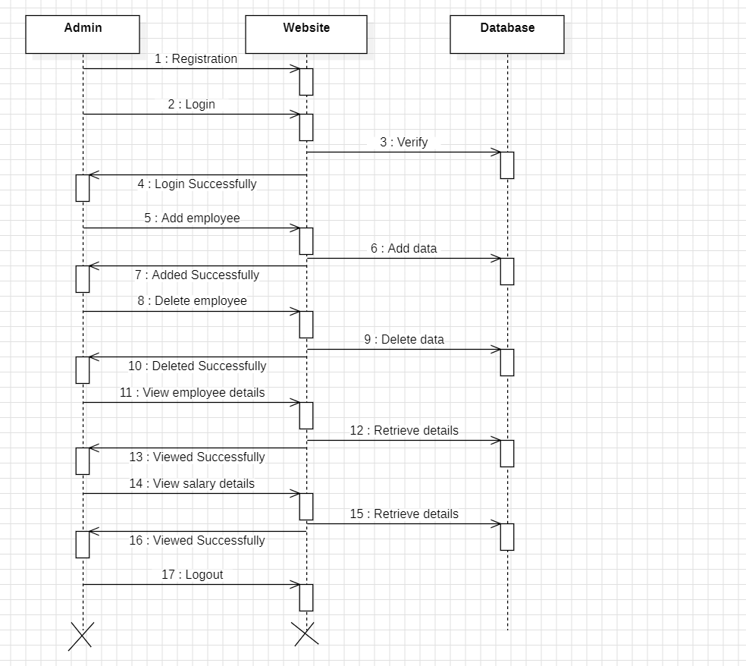

**Figure 3.3.3.1 Admin Sequence Diagram**

**16**

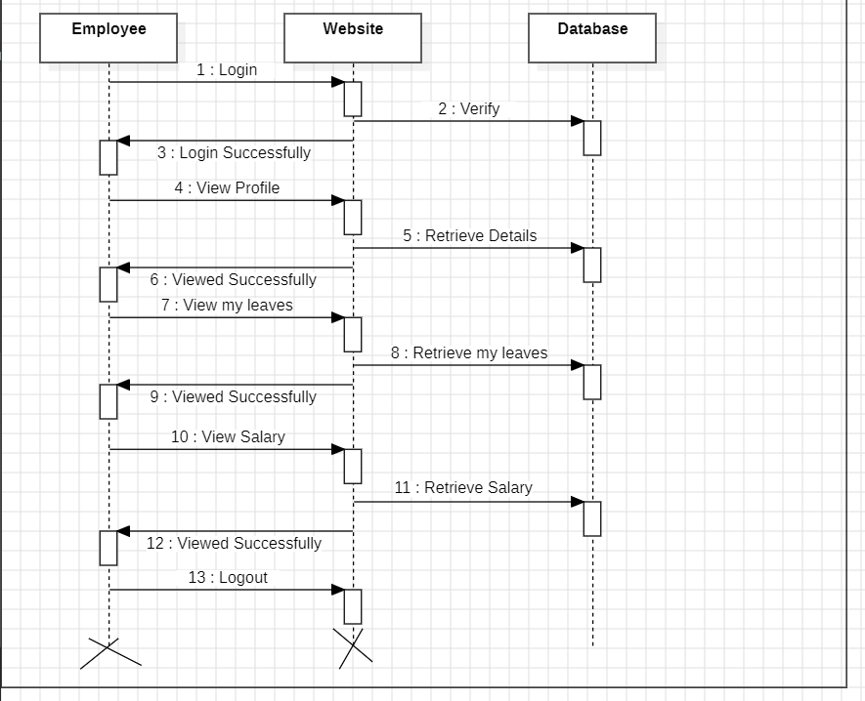

**Figure 3.3.3.2 Member Sequence Diagram**

**3.3.4 Collaboration Diagram:**

A collaboration diagram is an introduction diagram that emphasizes the structural organization of the objects that send and receive messages. Graphically a collaboration diagram is a collection of vertices and arcs.

**17**

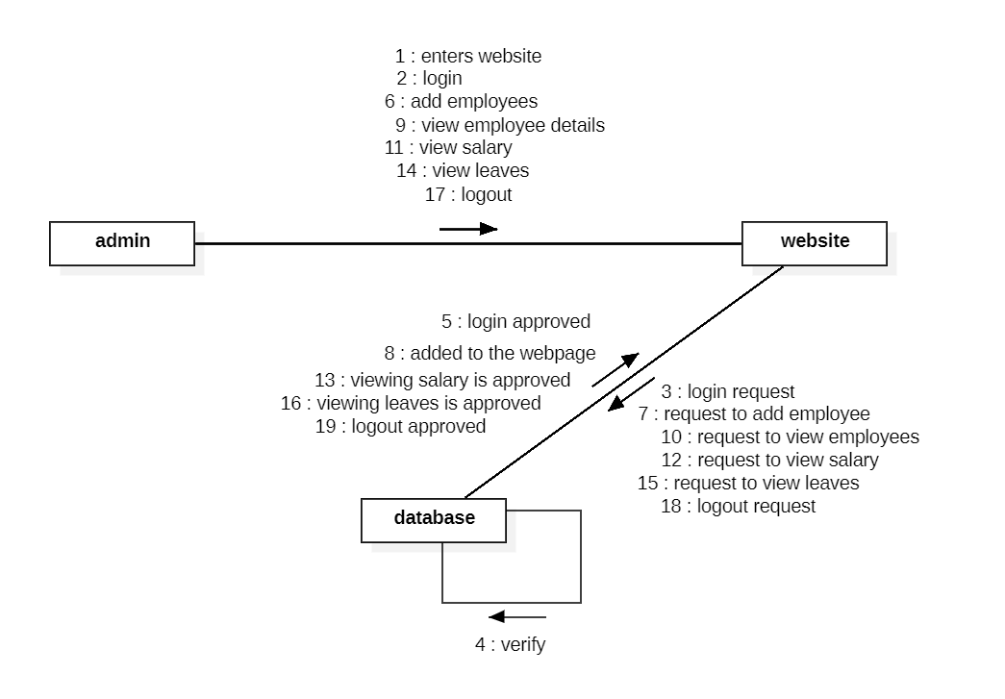

**Figure 3.3.4.1 Admin Collaboration Diagram**

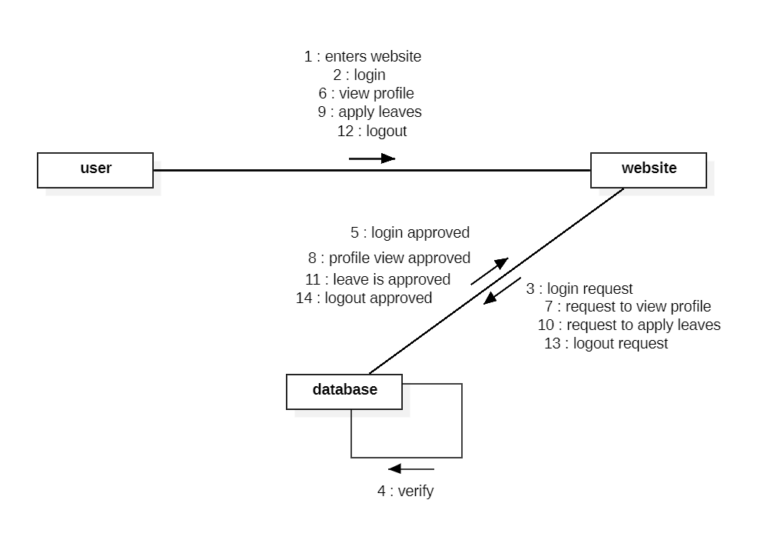

**Figure 3.3.4.2 User Collaboration Diagram**

**18**

**Employee Payroll Management** collaboration diagram **Figure 3.3.4.1 and 3.3.4.2** shows the objects involved in the process. In our case Admin, Database, Member are the main objects. Admin login to the website and login information is stored to database. The actions performed by the employee (user) are stored by database, employee can retrieve the information from database.

**3.3.5 Activity Diagram:**

An Activity Diagram is a behavioral diagram that shows the flow or sequence of activities through a system. The terms activity diagram and process flow are often used interchangeably. However, the term activity diagram is typically more restrictive as it refers to one of thirteen standard Unified Model Language (UML) diagrams. Activity Diagrams are one of the most commonly used diagrams since its notation and origin are based on the widely known flowchart notation.

The activity diagram in **Employee Payroll Management** shows the actions performed by admin, employee after login every action performed is mentioned in the diagram. The below **Figure 3.3.5.1 represents** the Employee Activity Diagram and **Figure 3.3.5.2** represents the Admin Activity Diagram.

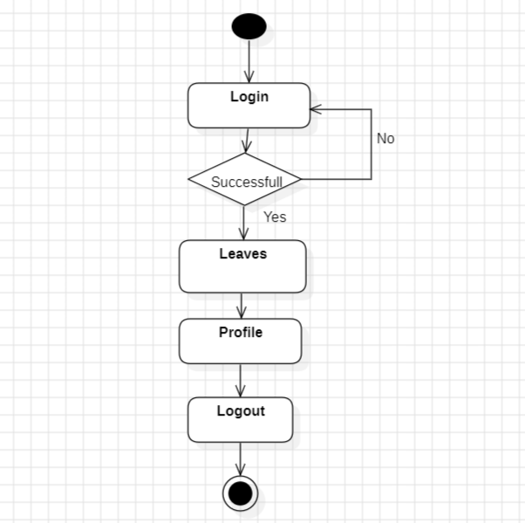

**Figure 3.3.5.1 Employee Activity Diagram**

Admin initially login to the website, then he has authentication of accessing website. Where he can perform operations, such as view booked slots, view feedbacks given by members and he can also delete negative i.e., abuse feedbacks.

**19**

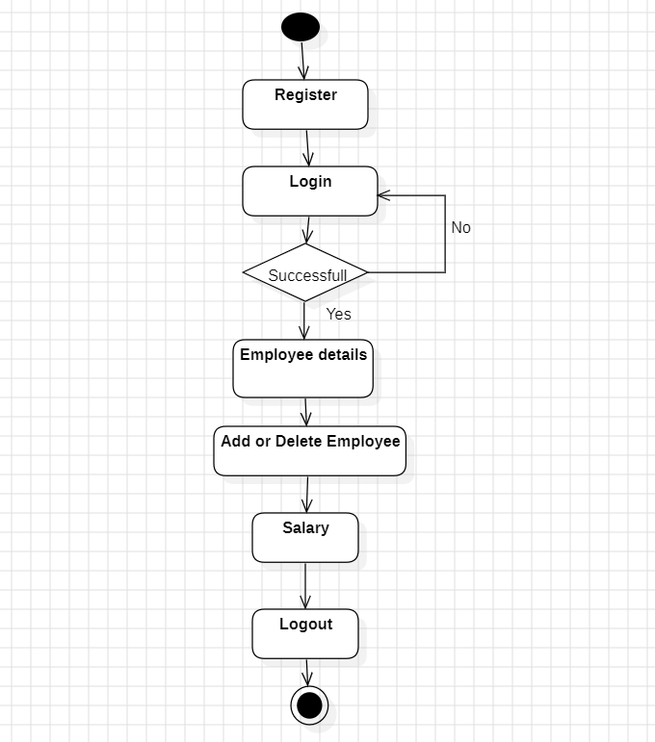

**Figure 3.3.5.2 Admin Activity Diagram**

Admin initially login to the website, then he has authentication of accessing website. Where he can perform operations, such as view booked slots, view feedbacks given by members and he can also delete negative i.e., abuse feedbacks.

**20**

**3.4 Database Dictionary**

A database dictionary, or Metadata Repository, as defined in the IBM Dictionary of Computing, is a "centralized repository of information about data such as meaning, relationships to other data, origin, usage, and format”. The term can have one of several closely related meanings pertaining to databases and database management systems (DBMS).

* + A document describing a database or collection of databases.
  + An integral component of a DBMS that is required to determine its structure.
  + A piece of middleware that extends or supplants the native data dictionary of a DBMS.

**3.4.1 Data Tables:**

**Data Base (MONGODB):**

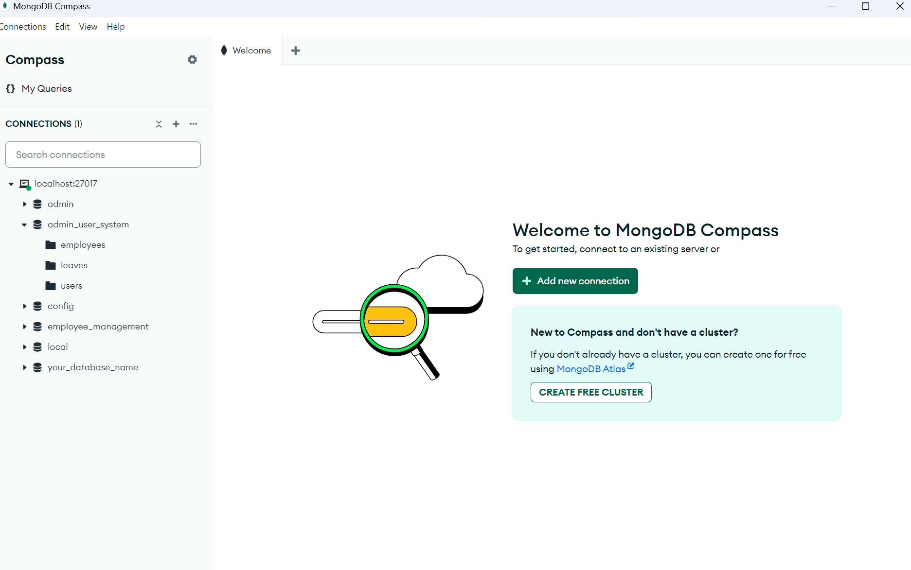

**Table 3.4.1.1 MongoDB**

**Data Base Details:**

* **Table Name:** DB Details Table
* **Table Description:** This table stores the details about the database.

**21**

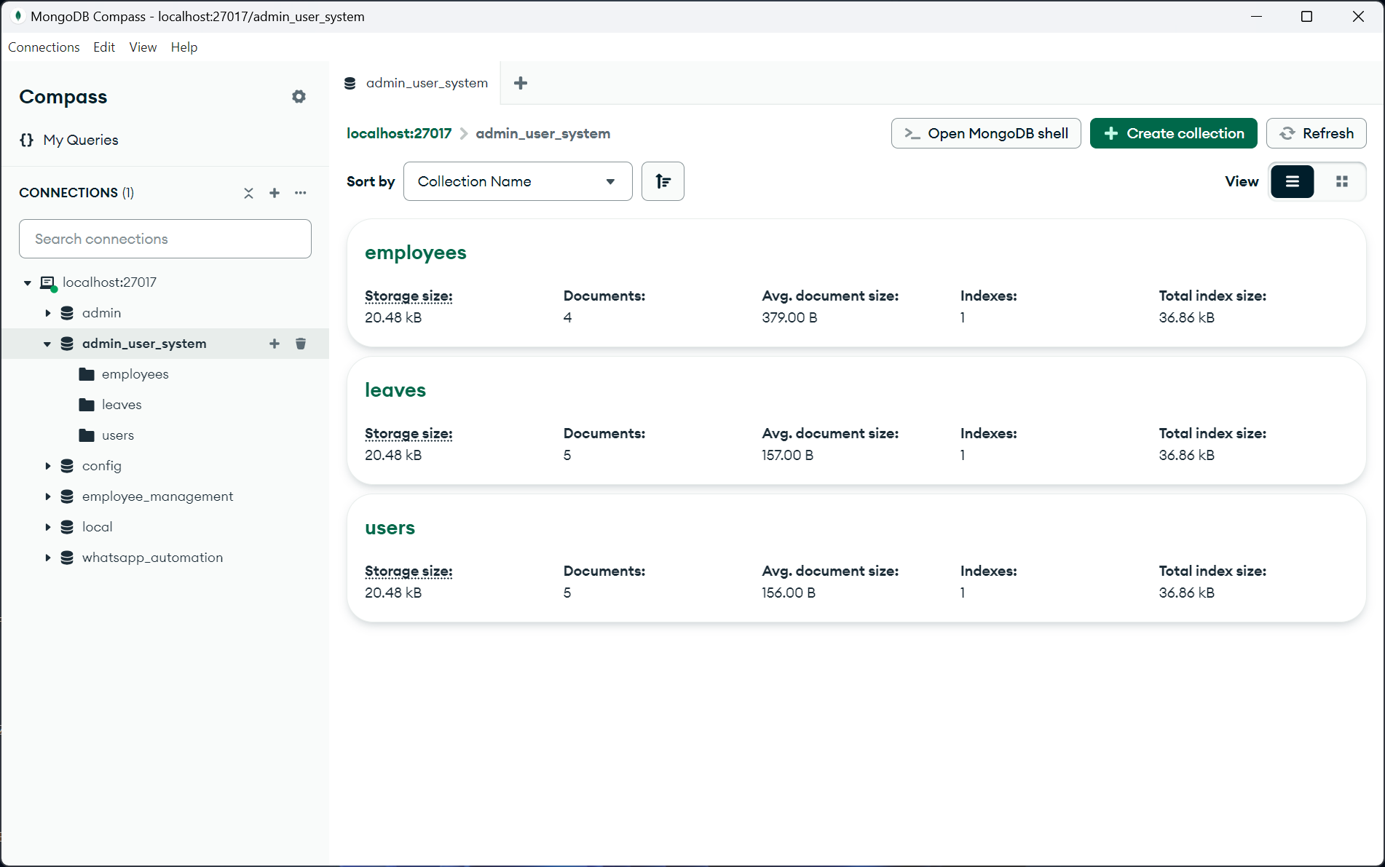

**Table 3.4.1.2 DB Collections Table**

**Employee Details Table:**

* **Table Name:** Employee Details Table
* **Table Description:** This table stores the information about Employees.

Admin can also view the details and can add them into database.

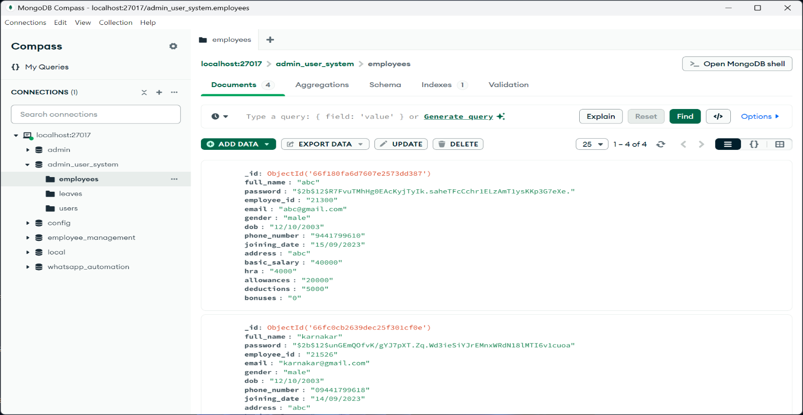

**Table 3.4.1.3 Employees Table**

**22**

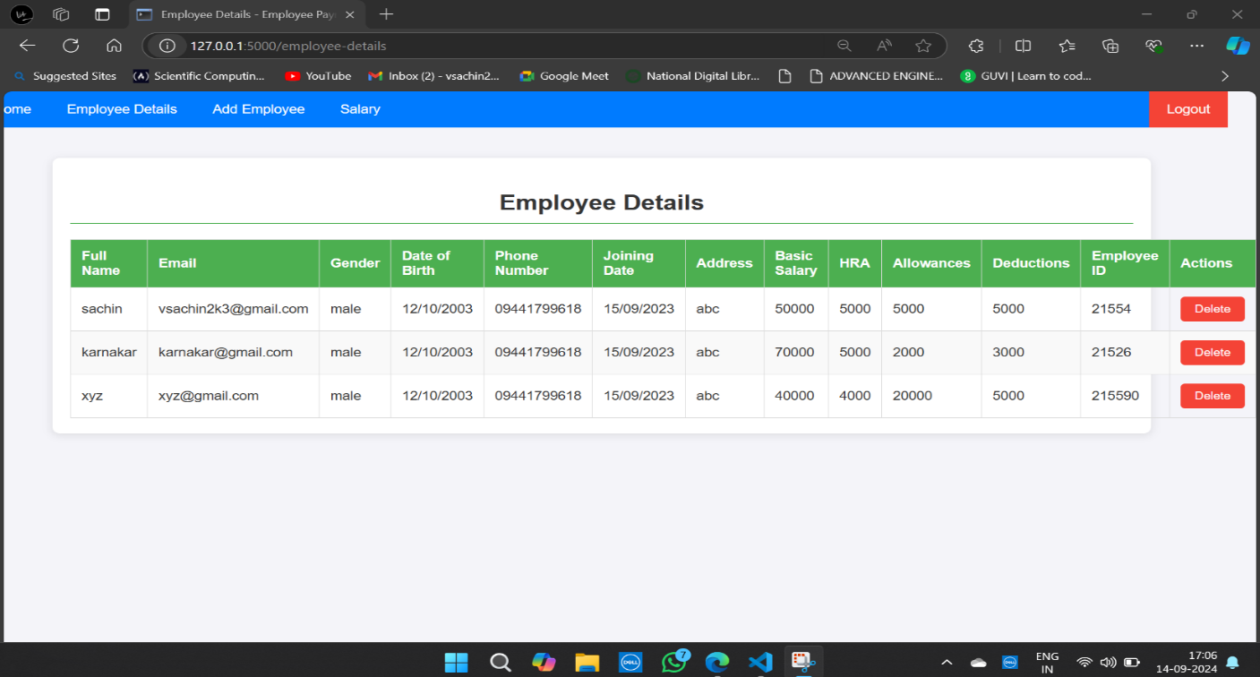

**Table 3.4.1.4 Employee Details Table (Admin View)**

**Leaves Table:**

* **Table Name:** Leaves Table
* **Table Description:** This table stores the information about the Leaves Application filled by Employees.

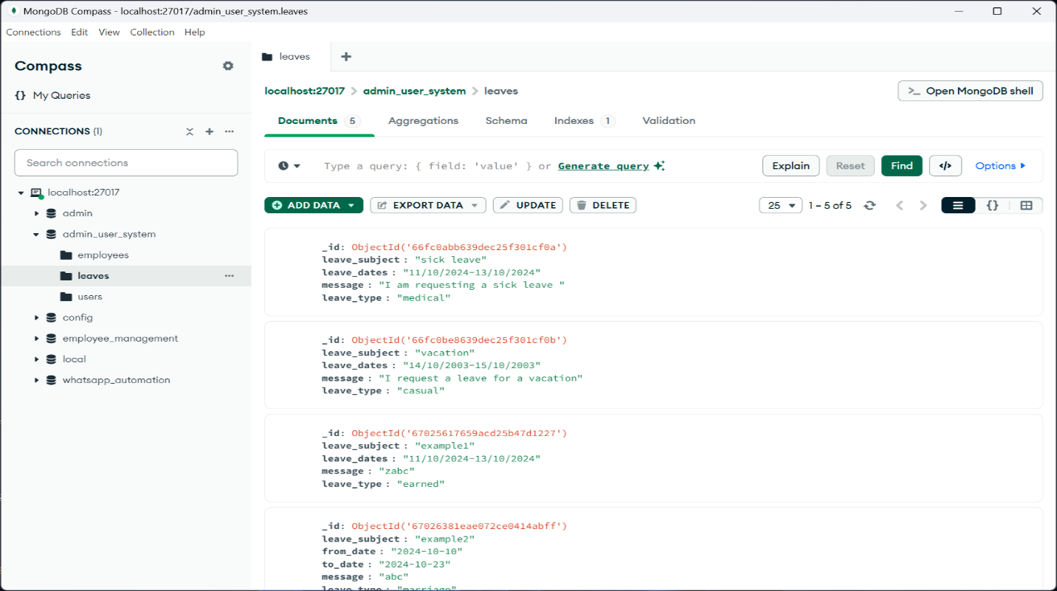

**Table 3.4.1.5 Leaves Table (Admin view)**

**23**

**CHAPTER 4**

**IMPLEMENTATION**

**4.1 LANGUAGES USED**

**4.1.1 PYTHON**

Python is a high-level, interpreted programming language known for its readability and versatility. Developed by Guido van Rossum and first released in 1991, Python has become one of the most popular programming languages due to its simplicity and broad range of applications.

**Features of Python:**

1. Readability and Simplicity

* Clean Syntax: Python emphasizes readability with its clear and straightforward syntax, which often resembles pseudo-code. This makes it easier for new programmers to learn and understand.
* Indentation: Python uses indentation (whitespace) to define code blocks, which enhances readability by enforcing a consistent visual structure.

2. Interpreted Language

* Python code is executed line-by-line by an interpreter, which makes it easier to test and debug. This also means that you don’t need to compile your code before running it.

3. Dynamic Typing

* Variables in Python do not need explicit type declarations. Types are determined at runtime, which allows for more flexible and faster development.

4. High-Level Language

* Python abstracts away many of the complex details of the computer's hardware, allowing you to focus more on solving problems than managing system resources.

5. Extensive Standard Library

* Python comes with a large standard library that includes modules and packages for handling a wide range of tasks, from file I/O to web development and data analysis.

6. Object-Oriented and Functional Programming

* Python supports multiple programming paradigms, including object-oriented programming (OOP), functional programming, and procedural programming.

7. Cross-Platform Compatibility

* Python is available on various operating systems, including Windows, macOS, and Linux. Code written in Python can often run on different platforms with little to no modification.

**24**

8. Extensive Ecosystem

* + Python has a rich ecosystem of third-party libraries and frameworks that extend its functionality. Popular libraries include NumPy and pandas for data science, Django and Flask for web development.

9. Community Support

* + Python has a large, active community of developers. This means extensive documentation, a wealth of tutorials, and a broad range of third-party tools and libraries.

10. Embeddable and Extensible

* + Python can be embedded within other applications and extended with C or C++ code. This makes it useful for integrating with other software and optimizing performance-critical components.

11. Interactive Mode

* Python provides an interactive mode (REPL) where you can test code snippets, explore libraries, and experiment with Python features on the fly.

12. Automatic Memory Management

* + Python handles memory management automatically through its built-in garbage collector, which reclaims memory from objects that are no longer in use.

**4.1.2 VISUAL STUDIO:** Visual Studio is a comprehensive integrated development environment (IDE) created by Microsoft. It is widely used for developing a variety of applications, from desktop and web applications to mobile apps and cloud-based solutions.

Key Features of Visual Studio

1. Rich IDE Experience:
   * Code Editor: Visual Studio offers a powerful code editor with features such as IntelliSense syntax highlighting, code refactoring.
   * Debugging Tools: The IDE provides advanced debugging capabilities, including breakpoints, watch windows, call stacks, and live debugging. You can debug both managed and native code.
2. Project and Solution Management:
   * Solution Explorer: This tool helps manage project files and dependencies, allowing for easy navigation and organization of your codebase.
   * Project Templates: Visual Studio includes numerous project templates for different types of applications, such as ASP.NET web apps, desktop apps, and mobile apps.

**25**

1. Version Control Integration:
   * Git Integration: Visual Studio supports Git, enabling version control directly within the IDE. It provides tools for managing repositories, committing changes, and resolving conflicts.
   * Team Foundation Version Control (TFVC): For teams using Microsoft's version control system, Visual Studio integrates with TFVC for source control management.
2. Extensibility:
   * Extensions and Add-ons: Visual Studio has a rich ecosystem of extensions available through the Visual Studio Marketplace.
   * Customizable UI: You can customize the IDE’s appearance and behavior, including tool windows, keyboard shortcuts, and themes.
3. Language Support:
   * Multilingual Support: Visual Studio supports a wide range of programming languages, including C#, C++, Visual Basic, F#, Python, JavaScript, and more.
4. Code Collaboration:
   * Live Share: Visual Studio’s Live Share feature allows developers to collaborate in real-time on code with others, enabling shared editing and debugging sessions.
5. Build and Deployment:
   * Deployment: Visual Studio supports various deployment options, including deployment to Azure, Docker containers, and on-premises servers.
   * Build Tools: Integrated build tools help compile and package applications. You can configure build settings and automate the build process using MSBuild and other tools.
6. Testing Frameworks:
   * Unit Testing: Visual Studio includes built-in support for unit testing frameworks such as MS Test, N Unit, and x Unit. You can write, run, and manage tests within the IDE.
   * Code Coverage: Tools for measuring code coverage and identifying untested parts of your code are also integrated.
7. Cloud Integration:
   * Azure Integration: Visual Studio provides tools for developing, deploying, and managing applications on Microsoft Azure. This includes integration with Azure DevOps and Azure App Services.

**26**

1. Cross-Platform Development:
   * Xamarin: For mobile development, Visual Studio integrates with Xamarin, allowing you to build cross-platform mobile apps for iOS and Android using C#.
   * Visual Studio Code: While not the same as the full Visual Studio IDE, Visual Studio Code is a lightweight, cross-platform editor that supports various programming languages and is popular for web development and scripting.

**4.1.3 HTML:** HTML is a hypertext mark-up language that is in reality a backbone of any website. Every website can’t be structured without the knowledge of HTML. If we make our web page only with the help of HTML, then we can’t add many of the effective features in a web page, for making a web page more effective we use various platforms such as CSS. So here we are using this language to make our web pages more effective as well as efficient.

**4.1.4** **CSS:**

CSS Stands for “Cascading Style Sheet.” Cascading style sheets are used to format the layout of Web pages. They can be used to define text styles, table sizes, and other aspects of Web pages that 35 previously could only be defined in a page’s HTML. The basic purpose of CSS is to separate the content of a web document (written in any mark-up language) from its presentation (that is written using Cascading Style Sheets CSS gives the option of selecting various style schemes and rules according to the requirements and it also allows the same HTML document to be presented in more than one varying style.

**4.1.5 JAVASCRIPT:** JavaScript is a high-level, interpreted programming language that is widely used for building interactive and dynamic web applications. It was originally developed by Netscape as a client-side scripting language for web browsers but has since evolved to become a versatile language used across various platforms. JavaScript’s ability to run in both the browser and on the server, combined with its extensive ecosystem of frameworks, libraries, and tools, makes it a cornerstone of modern web development and a versatile language for various programming needs.

**4.1.6 MONGODB:**

MongoDB is a popular NoSQL database management system designed to handle large volumes of unstructured or semi-structured data. It’s known for its flexibility, scalability, and performance.

**27**

**Use Cases**

1. **Web and Mobile Applications**:
   * **Flexible Data Model**: Ideal for applications that require rapid development and frequent changes to the data model, such as content management systems and e-commerce platforms.
2. **Real-Time Analytics**:
   * **Aggregation Framework**: Suitable for real-time analytics and reporting, where fast, ad-hoc queries and data aggregation are required.
3. **Internet of Things (IoT)**:
   * **Scalability**: MongoDB’s scalability and schema-less nature makes it a good fit for managing large volumes of data generated by IoT devices.
4. **Big Data**:
   * **Handling Large Datasets**: MongoDB’s ability to handle large volumes of data across distributed systems makes it suitable for big data applications.

**4.1.7 FLASK:**

Flask is a lightweight and flexible web framework for Python, designed to help developers build web applications quickly and with minimal complexity. It is known for its simplicity, ease of use, and fine-grained control over the components of a web application.Flask’s simplicity and flexibility make it a popular choice for developers who need a lightweight framework that can be tailored to fit various use cases, from small-scale applications to more complex systems.

**4.2 FRONTEND DESIGN**

**Homepage:**

The application's homepage, depicted in Figure 4.2.1, serves as a shared interface accessible to all system users. Accessible through the web application upon login, this page facilitates the login process for both administrators and regular users. Its primary function is to provide a centralized hub for navigation.

The admin/user homepage features eight distinct categories:

1. Home: Offers a starting point for users, providing general information or updates.
2. Employee Details: Furnishes Employee details about the application, its purpose, and perhaps the organization behind it.
3. Add Employee: Allows new users to register for the system, typically involving creating an account.

**28**

1. View Leaves: Allows administrators to view leave applications submitted by employees. The admin can approve or reject these requests based on company policies.
2. Salary: Provides a comprehensive overview of employee salaries. The admin can view salary details, including basic pay, allowances, deductions, and net salary.
3. Home**:** Serves as the landing page for users after logging in. It offers general information.
4. Profile: Displays the user's personal and professional information as stored in the system. The profile includes details like employee ID, name, department, email, contact information.
5. Leaves: This section allows users to apply for leaves by filling in details like the type of leave, start and end dates, and reason. Users can also track the status of their previous leave applications.
6. Salary**:** Users can view their salary details here, including breakdowns of basic pay, allowances, deductions, and net salary.

**Logo page:**

Below, Figure 4.2.1 represents the Logo page of our website.

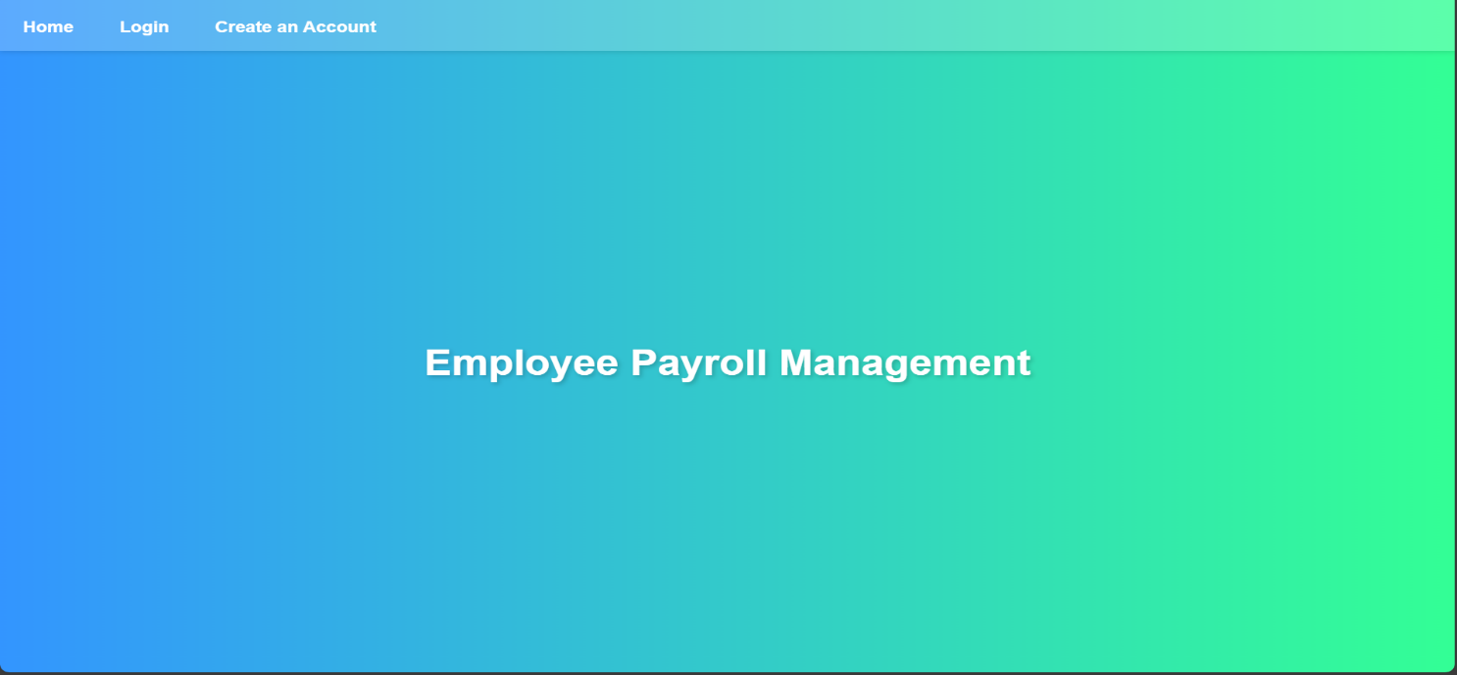

**Figure 4.2.1 Screenshot of Logo page**

**29**

**Login Page:**

Below, Figure 4.2.2 represents the login page. Here admin/user enters his/her login credentials. On clicking on the login button, admin/user will enter into the home page.

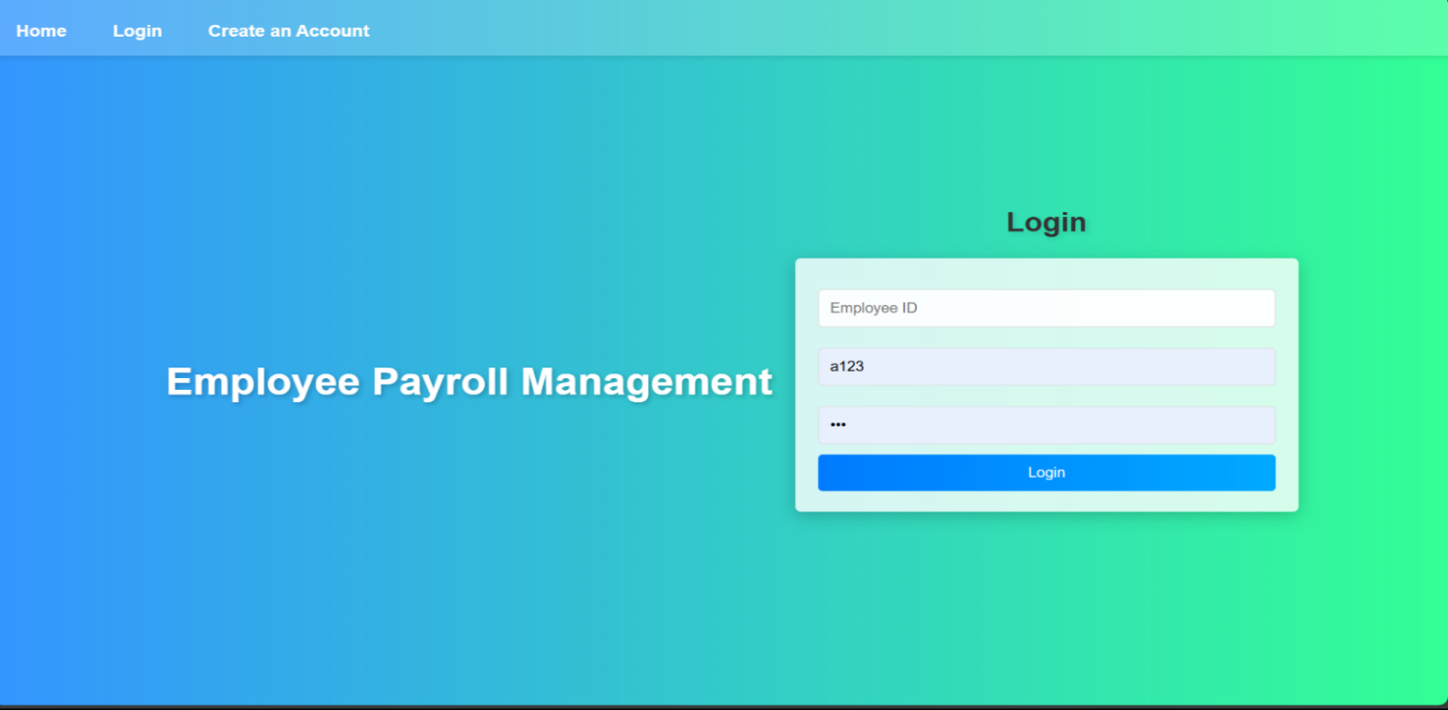  
**Figure 4.2.2 Screenshot of Login page**

**Registration Page:**

Below, Figure 4.2.3 represents the Registration page. Here admin/user enters his/her credentials. On clicking the register button, admin/user can create an account.

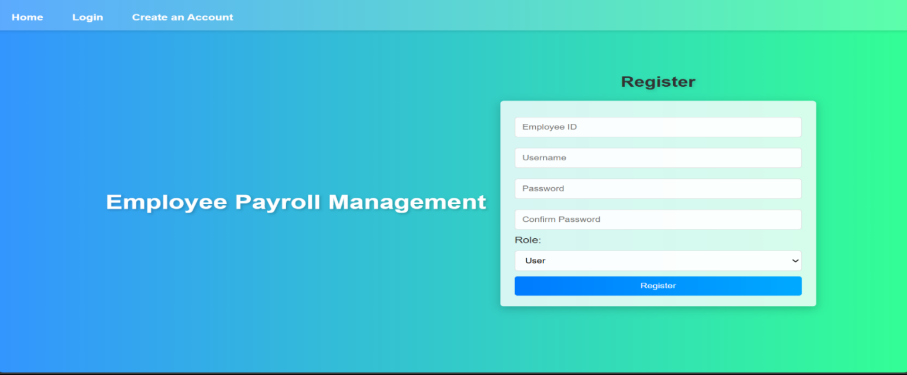

**Figure 4.2.3 Screenshot of Registration page**

**30**

**Admin Home Page:**

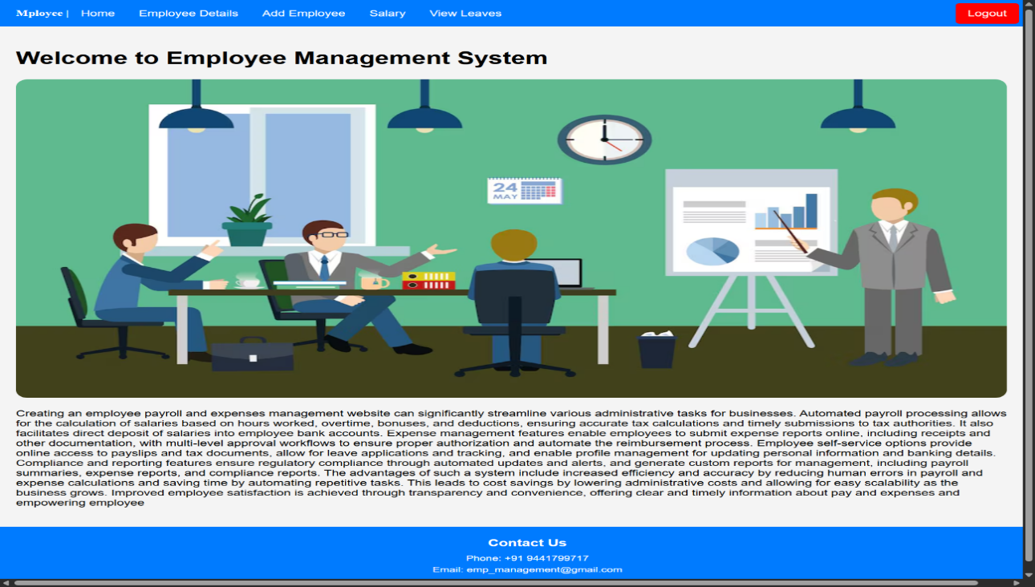Below, Figure 4.2.4 represents the Home page of our website.

**Figure 4.2.4 Screenshot of Admin Home Page**

**Employee Details Page:**

Below, Figure 4.2.5 represents the Employee Details page. This page is designed to display a list of all employees with their corresponding information. It allows the admin to view, or delete employee details and manage the employee database efficiently.

**31**

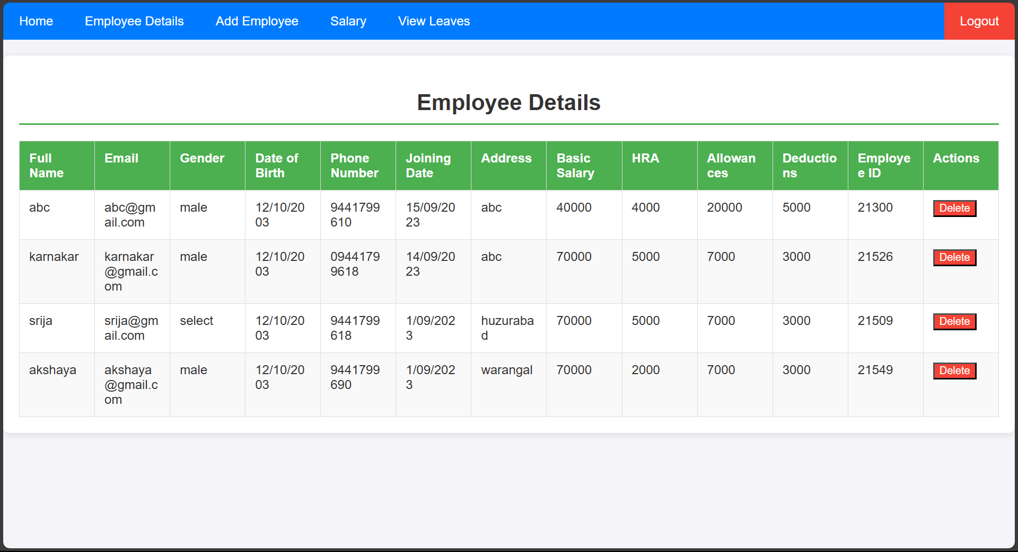

**Figure 4.2.5 Screenshot of Employee Details Page**

**Add Employee Page:**

Below, Figure 4.2.6 represents the Add Employee page. Here admin adds/enters the employee details to store in Database.

Here it features a structured form that collects essential employee information, which is then stored in a database for payroll and management purposes.

**32**

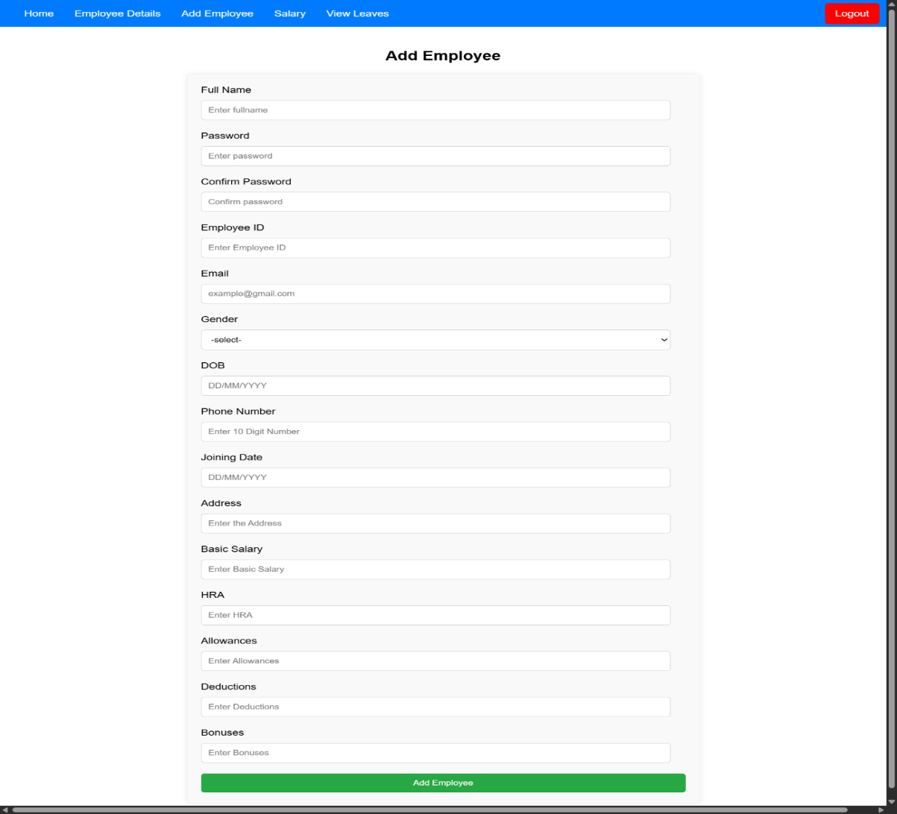

**Figure 4.2.6 Screenshot of Add Employee page**

**Salary Page:**

Below, Figure 4.2.7 represents the Salary page. Here Admin manages and view salary details for all employees. It provides a detailed breakdown of each employee's salary components.

**33**

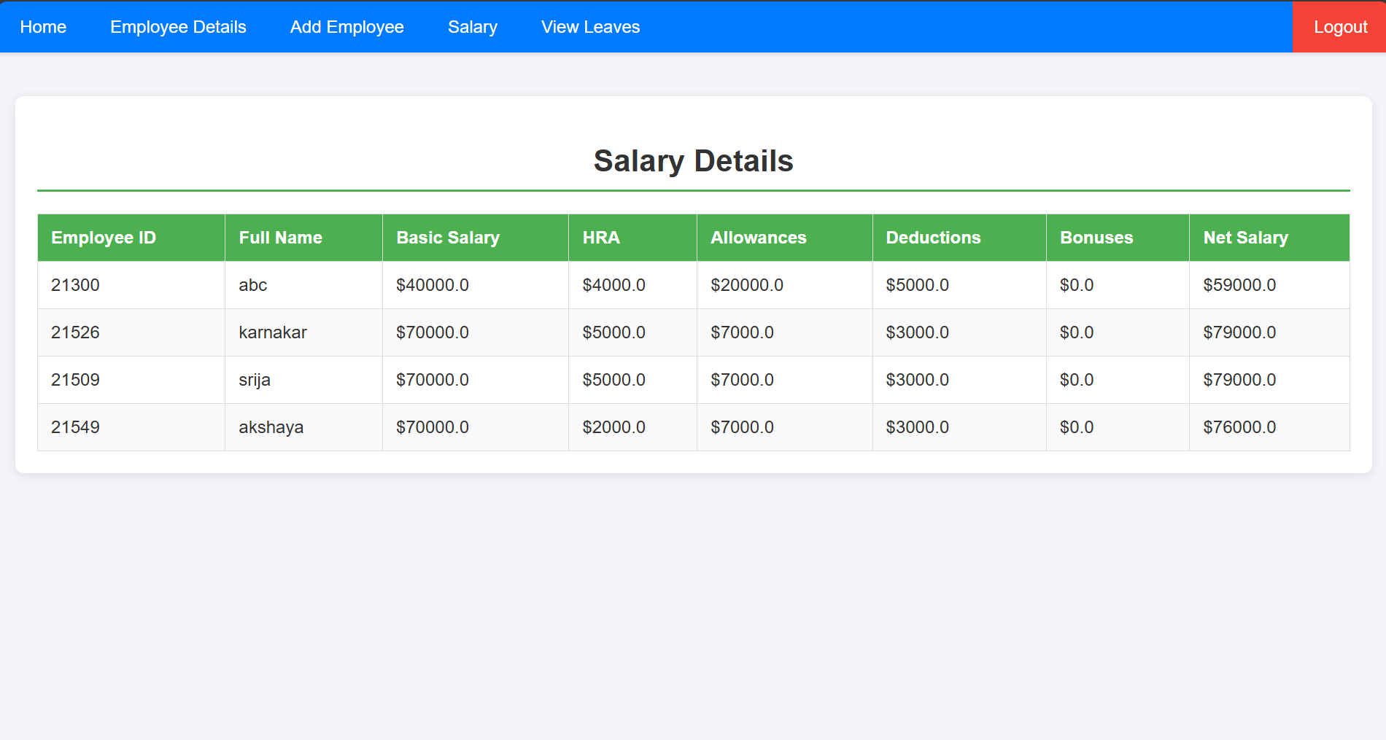

**Figure 4.2.7 Screenshot of Salary Details Page**

**View Leaves Page:**

Below, Figure 4.2.8 represents the View Leaves page. Here Admin manages and view Leave application details for all employees.

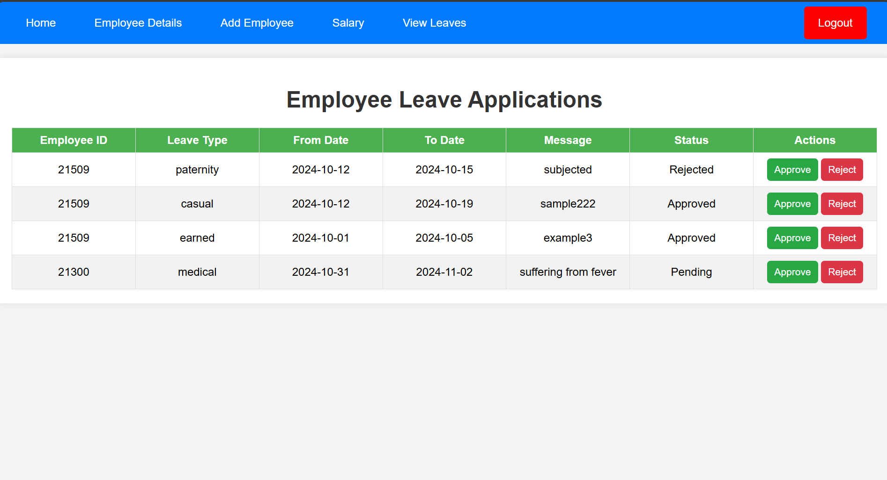

**Figure 4.2.8 Screenshot of View Leaves Page**

**34**

**User Home Page:**

Below, Figure 4.2.9 represents the User Home page.

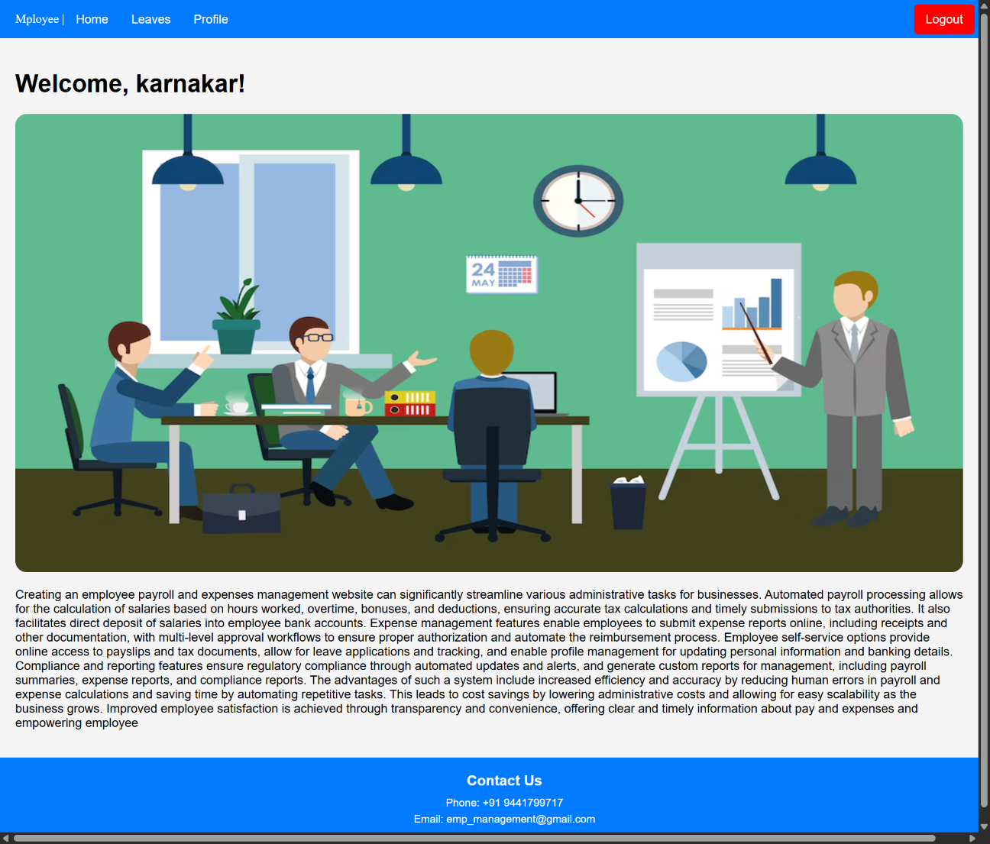

**Figure 4.2.9 Screenshot of User Home Page**

**Leaves Page:**

Below, figure 4.2.10 represents the Leaves page. It allows users to submit leave applications and view the status of their past leave requests or history.

**35**

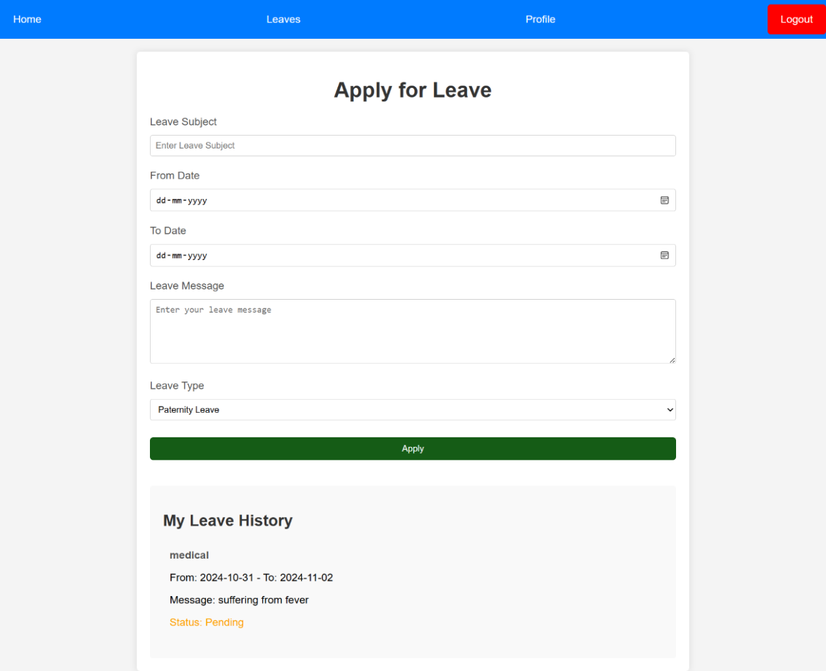

**Figure 4.2.10 Screenshot of Leave Application Page**

**Profile Page:**

Below, figure 4.2.11 represents the Profile page. It allows users to view their profile and salary information.

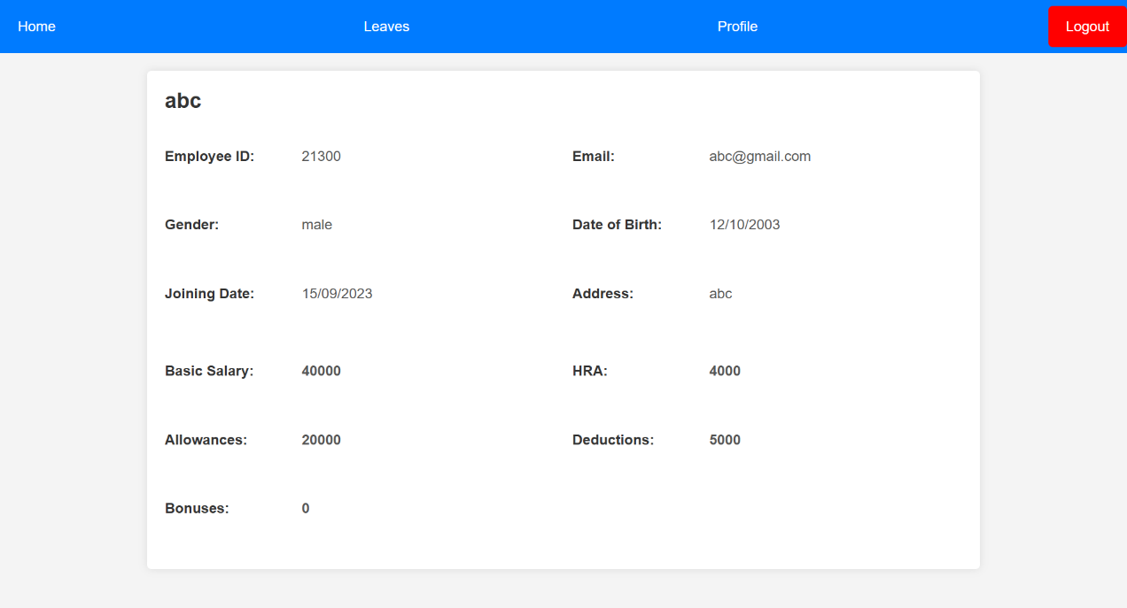

**Figure 4.2.11 Screenshot of Profile Page**

**36**

**CHAPTER 5**

**TESTING**

**5.1 TESTING**

"EMPLOYEE PAYROLL MANAGEMENT" functionality of the project is tested and it is the process of executing a program with the intent of finding an error. A good test case is one that has a high probability of finding an undiscovered error. Conducting tests for electric bikes rental services can help optimize efficiency, assess reliability, and ensure seamless user experience. Consider factors like response time, accuracy in delivery, and overall system performance during the testing phase. A successful test is one that uncovers an undiscovered error. Software testing is usually performed for one of two reasons:

* Defect Detection
* Reliability estimation

**Admin/User Login Page:**

* Figure 5.1.1 shows attempting login by leaving Employee id, username and password fields empty.
* Figure 5.1.2 shows trying to login by leaving Employee id, username and password fields filled.
* Figure 5.1.3 shows admin dashboard to display all admin related pages.
* Figure 5.1.4 shows user dashboard to display all user related pages.

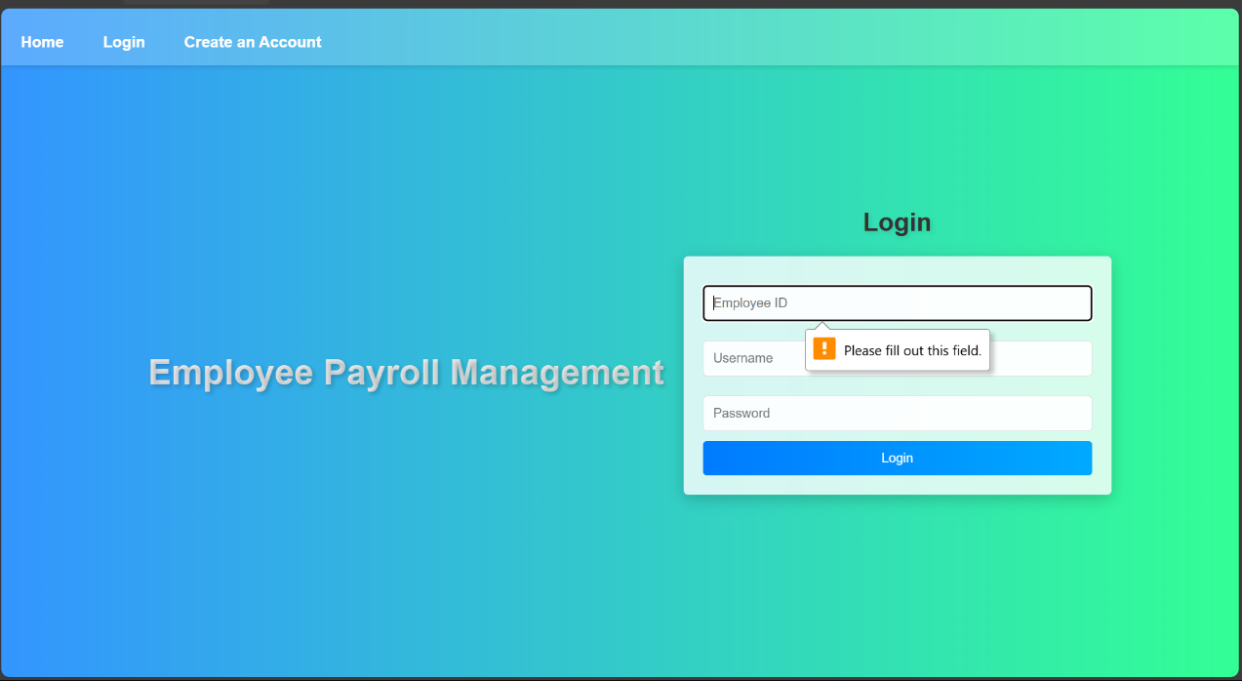

**Figure 5.1.1 All fields are empty**

**37**

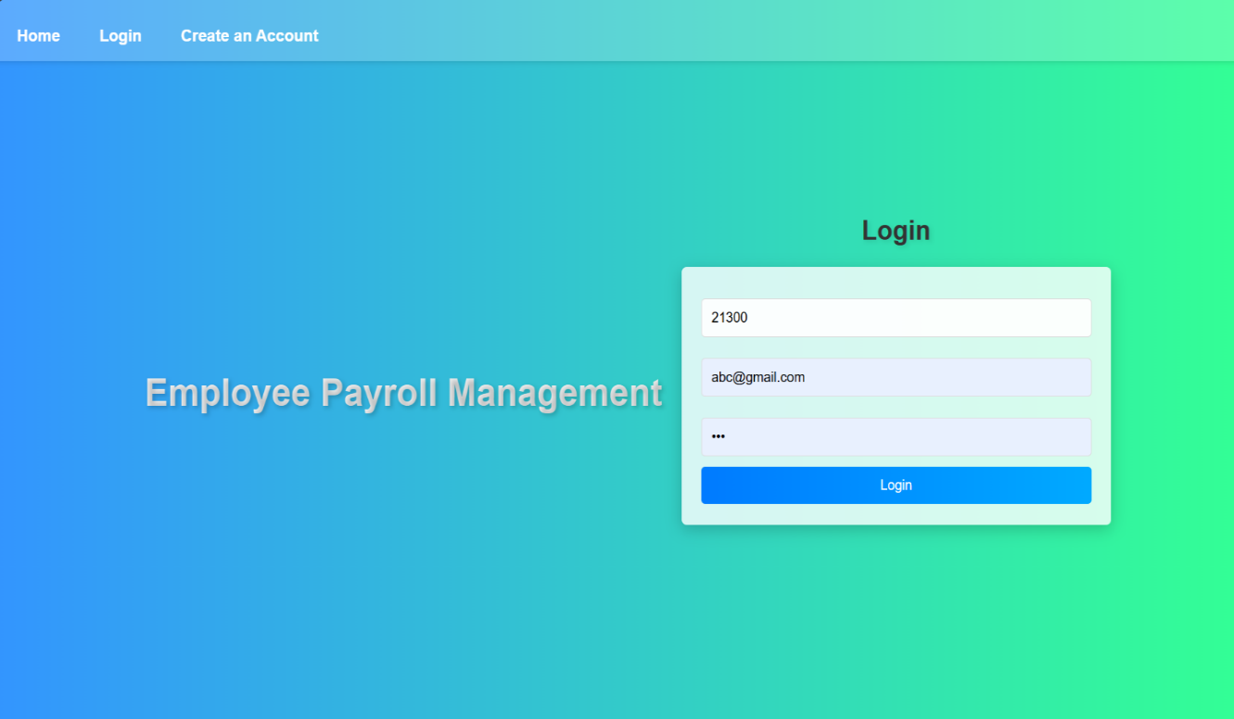

**Figure 5.1.2 All fields are filled**

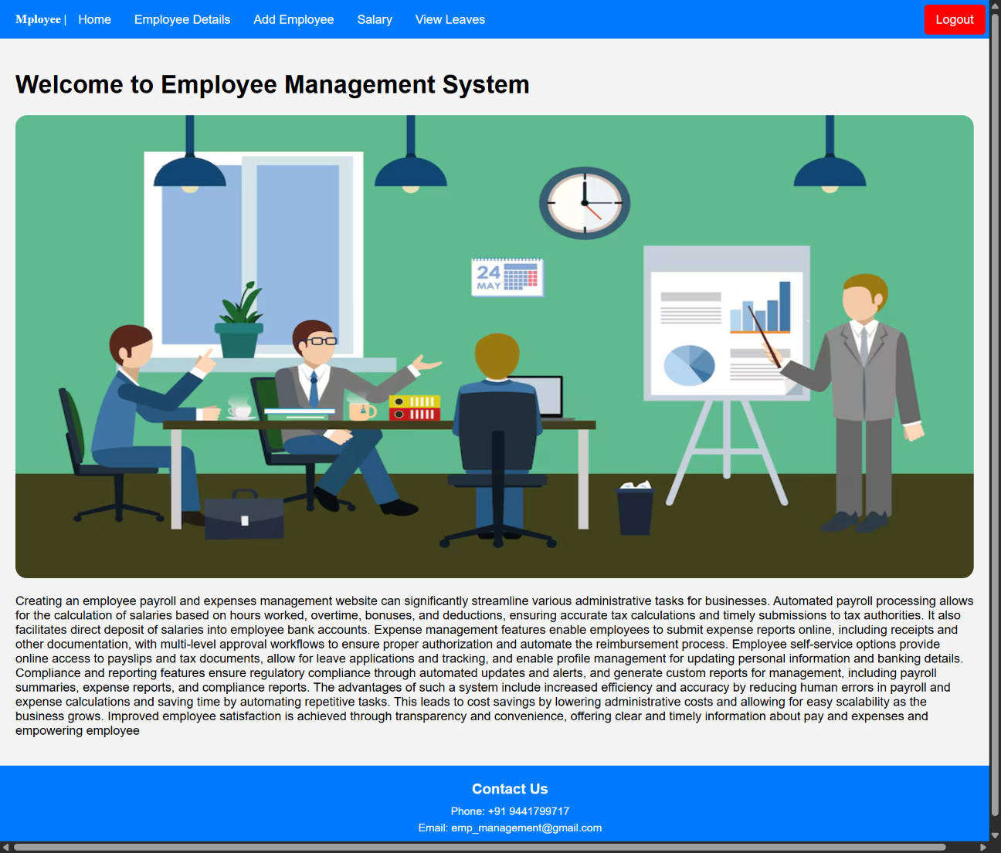

**Figure 5.1.3 Admin Home page**

**38**



**Figure 5.1.4 User Home Page**

**5.2 TEST STRATEGY**

Field-testing is performed manually, and functional testing is written in detail.

**Test Objectives:**

1. All field entries must work properly.
2. Pages must be activated from the identified link.
3. The entry screen, messages and responses must not be delayed.

**Features to be tested:**

1. Verify that entries are in correct format.
2. No duplicate entries should be allowed.
3. All links should take the user to the correct page.

**39**

**5.3 BLACK BOX TESTING**

The base of the black box testing strategy lies in the selection of appropriate data as per functionality and testing it against the functional specifications in order to check for normal and abnormal behaviour of the system. Now a days, it is becoming to route the testing work to a third party as the developer of the system knows too much of the internal logic and coding of the system which makes it unfit to rest application by the developer.

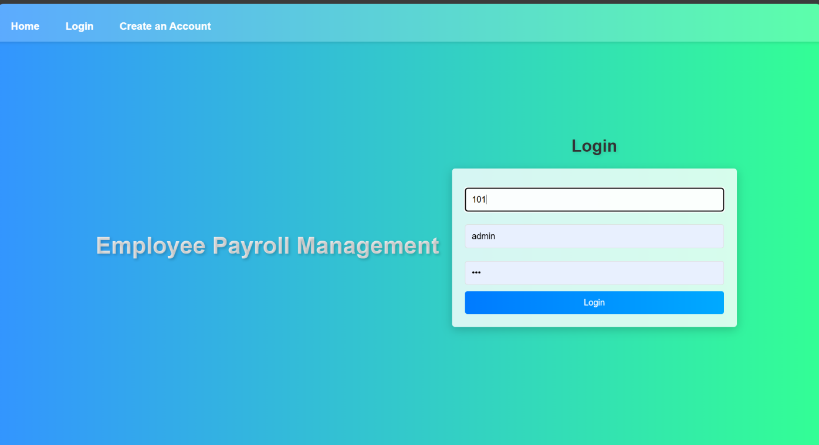



**Figure 5.3.1 The admin has logged in successfully**

**40**

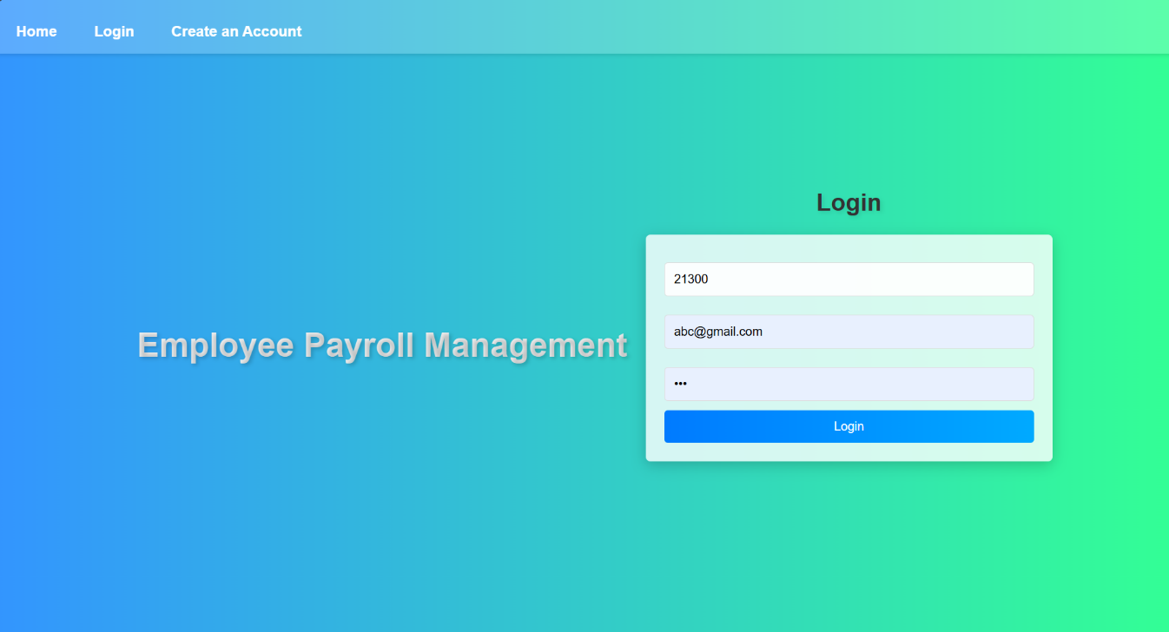



**Figure 5.3.2** **The User has logged in successfully**

**41**

Black box testing represents a method in software testing where the evaluator scrutinizes an application's functionality without accessing its internal code or implementation intricacies [10] In the provided Figure 5.3.1, 5.3.2, the administrator/user successfully authenticates by inputting valid credentials, exemplifying the principles of black box testing. This methodology emphasizes the systematic assessment of inputs and outputs, ensuring adherence to specified requirements without necessitating an understanding of the internal code structure. The depicted illustration underscores the user-centric nature of black box testing, signifying its pivotal role in validating system behaviour from an end-user perspective, independent of internal technical nuances. This systematic approach contributes significantly to comprehensive quality assurance and the effective validation of system functionality.

**5.4 WHITE BOX TESTING**

White box testing requires access to source code. Though white box testing can be performed any time in the life cycle after the code is developed, it is a good practice to perform white box testing during unit testing phase [1]. In designing of database, the flow of specific inputs through the code, expected output and the functionality of conditional loops are tested.

1. Guarantee that all independent paths have been executed.
2. Executed all logical decisions on their true and false sides.
3. Executed all loops at their boundaries and within their operational bounds.
4. Executed internal data structures to ensure their validity.

Unlike black box testing that only checks if a system works from the outside, white box testing dives into the internal mechanics of the application. In Figure 5.4, we performed white box testing by purposely feeding the login process wrong information, particularly examining how the system manages admin authentication. This method grants us the ability to closely inspect the application's inner workings, revealing potential weaknesses. By deliberately probing the system's logic with incorrect data, we aim to identify and address vulnerabilities, ensuring a robust and secure application.

Advantages of White Box Testing:

* Testing can commence even before the GUI is ready.
* Code optimization by finding hidden errors.
* White box test cases can be easily automated.
* It can provide stability and usability of the test cases.

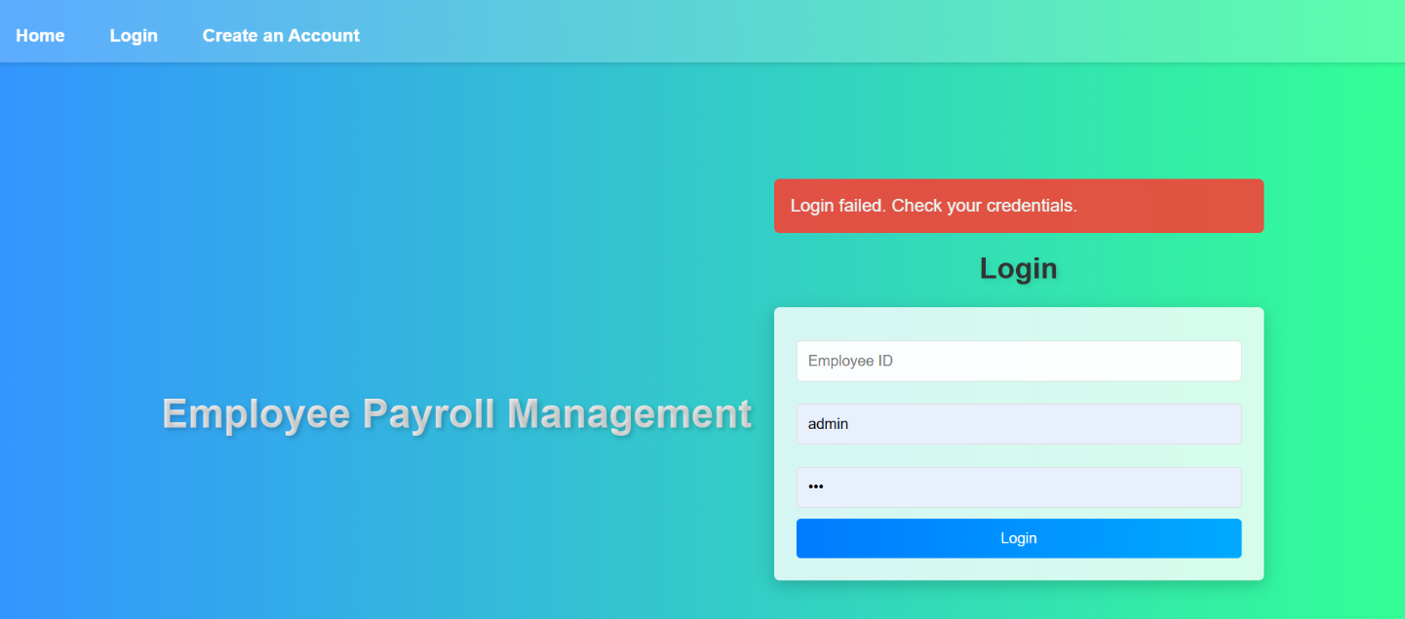

**Figure 5.4 The admin/user has failed because of invalid login credentials**

**42**

**5.5 DATABASE TESTING**

This test involves testing (Figures 5.5.1&5.5.2) whether the values entered through the form gets stored and saved in the database correctly or not.

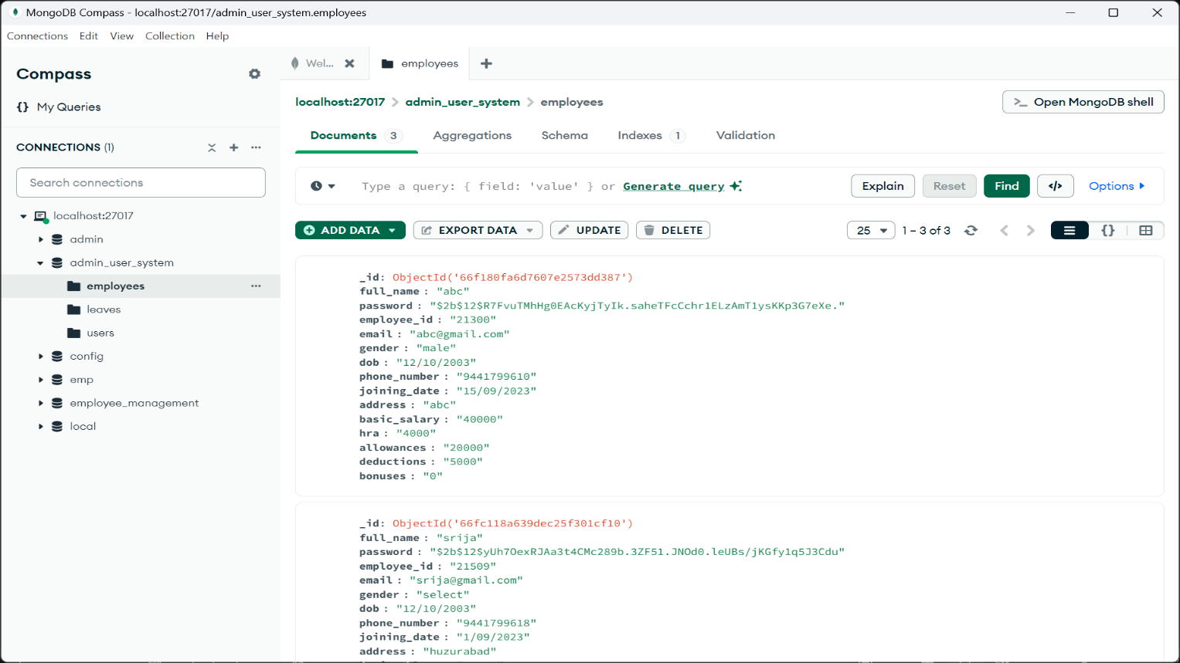

**Figure 5.5.1 Database Employee details**



**Figure 5.5.2** **Database Employee details data**

**43**

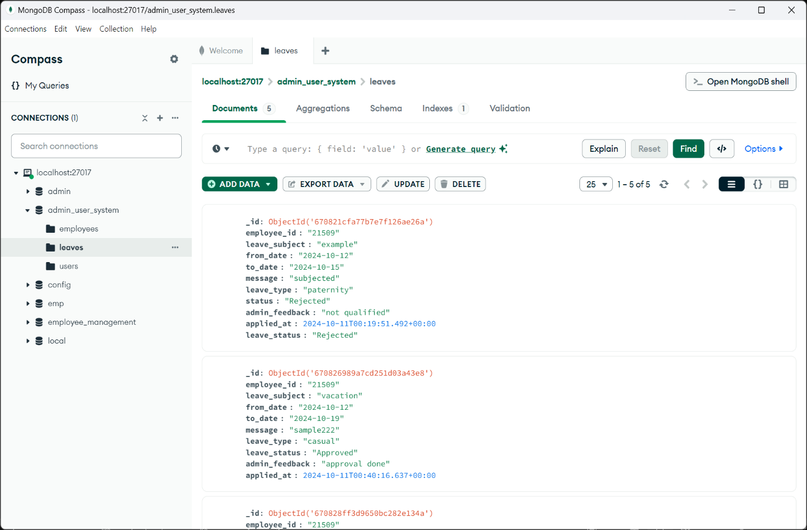

**Figure 5.5.3 Database Leaves**

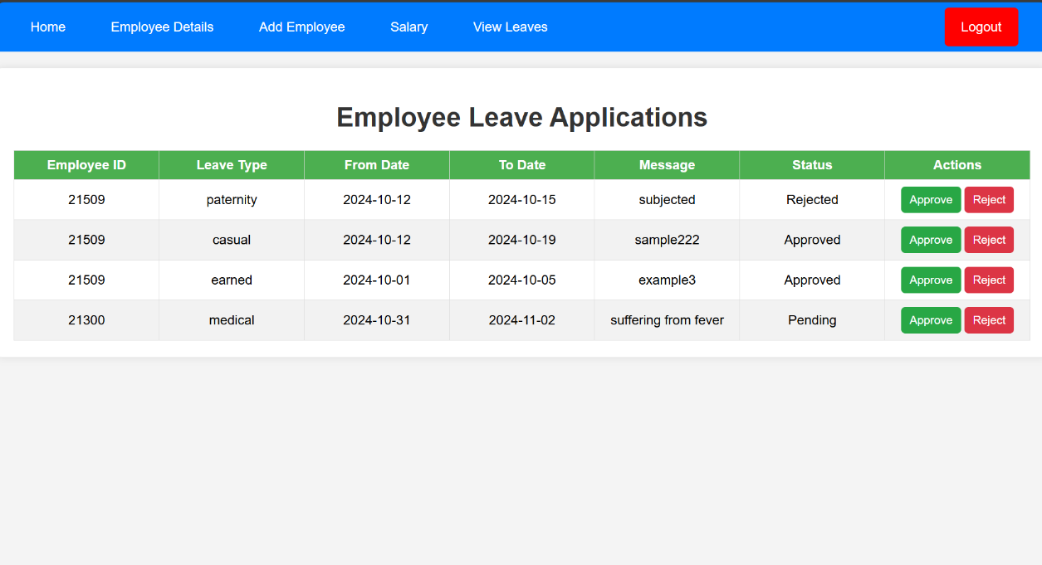

**Figure 5.5.4 Database Leaves data**

**5.6 ACCEPTANCE TESTING**

Testing is conducted to ensure that a product aligns with the specified requirements of the customer. The acceptance test suite is executed using supplied input data, and the obtained results are then compared with the expected outcomes defined by the client. In this case, a correct match was achieved. Figure 5.6 illustrates the process of acceptance testing.

**44**

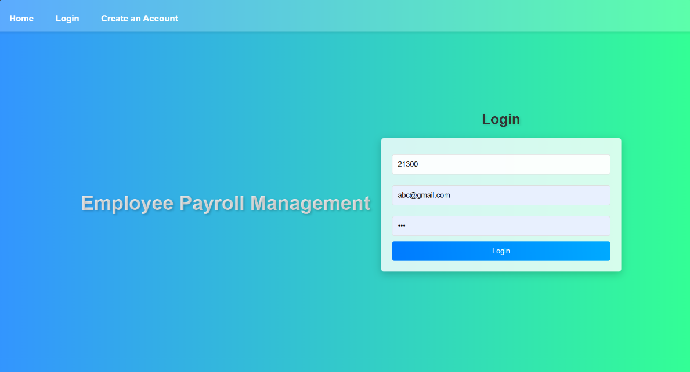

**Figure 5.6 Acceptance Testing**

**Test cases:**

* **Test case**: Admin/User logged (successful).
* **Test Description**: Provide Admin/User right by checking the details.
* **Pre-Condition**: Database connectivity.
* **Action Performed**: Entered valid login details without leaving any field.
* **Expected Results**: Successful login.
* **Condition Verified**: Yes.
* **Result**: Success.

**6.7 Test Results**

Test cases are done on every page on this website. All the test cases are passed successfully. No defects were encountered.

**45**

**CHAPTER 6**

**RESULTS**

**The result screenshots are as follows:**

**Screenshot for Homepage**

Below Figure 6.1 shows the homepage of the website, the feature of the homepage is to allow the user and Admin to navigate through the site. This page shows the navigating categories.

There are few categories:

**Admin**

1. Home
2. Employee Details
3. Add Employee
4. Salary
5. View Leaves

**User**

1. Home
2. Profile
3. Leaves



**Figure 6.1 Screenshot of Admin Home Page**

**46**

**Screenshot of Employee Details page:**

The Figure below (Figure 6.2) shows Employee Details page.



**Figure 6.2 Screenshot of Employee Details Page**

**Screenshot of a Add Employee page:**

The Figure below (Figure 6.3) shows add employee page.

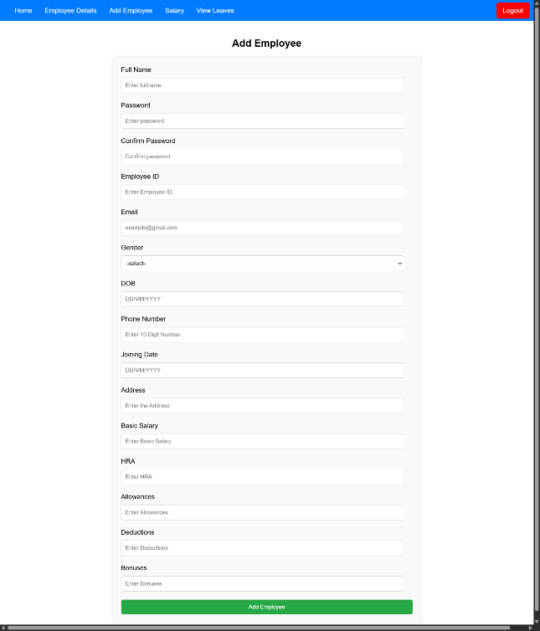

**Figure 6.3 Screenshot of Add Employee Page**

**47**

**Screenshot of a Salary page:**

The Figure below (Figure 6.4) shows salary page.



**Figure 6.4** **Screenshot of a Salary page**

**Screenshot of a View Leaves page:**

The Figure below (Figure 6.5) shows view leaves page.



**Figure 6.5 Screenshot of View Leaves Page**

**48**

**Screenshot of a User Home page:**

The Figure below (Figure 6.6) shows salary page.



**Figure 6.6 Screenshot of User Home Page**

**Screenshot of a leaves page:**

The Figure below (Figure 6.7) shows leaves page.

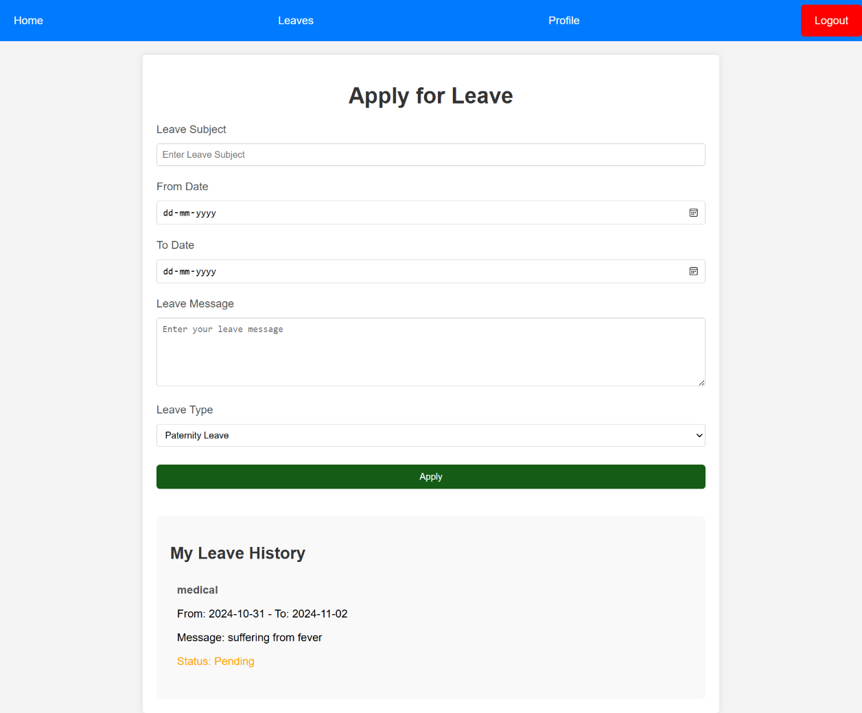

**Figure 6.7 Screenshot of a leaves page**

**49**

**Screenshot of a Profile page:**

The Figure below (Figure 6.8) shows profile page.



**Figure 6.8 Screenshot of Profile Page**

**50**

**CHAPTER 7**

**CONCLUSION**

The developed Web application, titled **Employee Payroll Management System**, is built using Python and Flask, offering a comprehensive solution to streamline payroll processes, employee management, and leave tracking. With a combination of user-friendly interfaces, secure authentication, and role-based access control, the system ensures efficiency, accuracy, and user satisfaction. It provides seamless management of employee details, salary records, leave applications, and profile updates, contributing to the success of the application.

By integrating functionalities such as secure login, leave management, and salary details, the project addresses the core needs of a modern payroll system. The addition of feedback mechanisms and future scalability options positions the system as a valuable tool for organizations. Overall, the **Employee Payroll Management System** not only full fills the immediate requirements of employee management but also sets a strong foundation for future enhancements, aligning with contemporary business needs and improving operational efficiency.

**51**

**CHAPTER 8**

**FUTURE SCOPE & ENHANCEMENTS**

As the **Employee Payroll Management System** project evolves, several opportunities for expansion and refinement can enhance its overall functionality, user experience, and scalability. Below are the potential future scope and enhancements for the system:

1. **Expansion of User Roles and Access:**
   * **Additional Roles:** Introduce more user roles such as HR managers, department heads, and finance teams, each with customized permissions to manage specific areas of employee data and payroll processes.
   * **Multi-Company Support:** Expand the system to allow multiple companies or departments to use the same platform, facilitating payroll management for organizations with diverse structures.
2. **Advanced Payroll and Tax Management:**
   * **Tax Calculations:** Incorporate automatic tax calculations based on regional tax regulations, including income tax, social security, and other deductions, for more accurate payroll processing.
   * **Bonus and Incentives Management:** Add features to manage bonuses, incentives, and performance-based payments, providing a comprehensive salary management module.
3. **Technological Advancements:**
   * **Cloud Integration:** Migrate the system to the cloud for better scalability, security, and ease of access. This would allow employees and administrators to access the system from anywhere at any time.
   * **Mobile App Development:** Develop a mobile application to complement the web platform, enabling employees to view payslips, apply for leaves, and update their profiles on the go.
   * **AI-Driven Insights:** Integrate artificial intelligence for predictive analytics in payroll trends, helping businesses optimize employee management and salary distribution.
4. **Automation and Workflow Enhancements:**
   * **Automated Leave and Attendance Tracking:** Implement automated leave tracking with integration into biometric or online attendance systems for seamless management of employee leaves and attendance records.
   * **Automated Notifications:** Introduce automated email and SMS notifications for employees regarding salary disbursement, tax filing reminders, and leave approvals.

**52**

**BIBLIOGRAPHY**

[1] The Unified Modelling Language User Guide, 2nd edition by Grady Booch.

[2] Database Management Systems, 3rd edition by Raghu Rama Krishnam.

[3] Methodologies for Software Testing. 3rd edition by Dr Nazeer shaik, Dr Asadi

Srinivasulu.

[4] Visual Studio App Development with “Visual Studio App Development: A

Beginners Guide” by Packt Publishing.

[5] python with “Python Web Development with Flask and MongoDB” by Jose

Manuel Ortega Published by Packt Publishing.

[6].HTML and CSS with “HTML and CSS: Design and Build Websites” by Jon

Duckett.

[7] Fundamentals of Database System, 5th edition by Ramez Elmasri. Shamkant

B. Navathe.

[8] Software Testing A craftsman s Approach, 4th edition by Paul C. Jorgensen.

**53**